



*****Laboratory Script***

**Customized Embedded  
Processor Design for IoT**

This work uses ASIP Meister developed by PEAS Project, Osaka University.

5/6/2020

**Table of contents**

1 Introduction 4

1.1 Application Specific Instruction Set Processors 4

1.2 ASIP Design Flow 5

1.3 Custom Instruction Identification 6

1.4 Goal of the Laboratory 8

2 Working Environment 9

2.1 Network Structure 9

2.2 Basic UNIX Commands/Programs 10

2.2.1 Remote Operation 13

2.2.2 X2Go Client 14

2.3 Directory Structure 15

3 Dlxsim 22

3.1 Brownie STD 32 Architecture 22

3.2 Extending dlxsim 27

3.2.1 Startup Parameters for dlxsim 27

3.2.2 How to Add a New Instruction 28

3.2.3 How to Add a New Instruction-Format 29

3.3 Using dlxsim 30

3.3.1 Statistics 31

3.3.2 Debugging with dlxsim 32

4 ASIP Meister 34

4.1 What is ASIP Meister? 34

4.2 Processor Design Flow Using ASIP Meister 35

4.3 Typical Challenges while Working with ASIP Meister 36

4.4 Tutorial for the “Flexible Hardware Model” (FHM) 36

4.4.1 Setting up ASIP Meister to add new FHM 37

4.4.2 FHM structure 37

4.4.3 Estimation and the Synthesis Model 40

4.4.4 Testing the new FHM 41

4.5 Multi Cycle FHMs 41

4.5.1 Estimation, Synthesis, ASIP Meister usage and Testing 44

4.6 General Hints about FHMs 45

4.7 Synthesizable VHDL code 45

5 ModelSim 47

5.1 Tutorial 47

5.1.1 Create a new ModelSim Project 47

5.1.2 Adding the Testbench and ASIP Meister CPU files 49

5.1.3 Compile the project 49

5.1.4 Run the simulation 49

5.1.5 Statistics of the Simulation 51

5.2 General Hints 53

6 Validating the CPU in Prototyping Hardware 55

6.1 Creating the ISE Project 55

6.2 Adding Source Files to ISE Project 56

6.3 Synthesizing and Implementing the ISE Project 58

6.4 Initializing FPGA Internal Memory with your Application 58

6.4.1 Uploading the Bitstream to FPGA Board 59

6.4.2 Initializing and Using the External SRAM 60

6.4.3 Hardware Specific Limitations of the Application 61

6.5 Getting Accurate Area, Delay and Critical Path Reports 62

6.5.1 Creating ISE Project for Getting Accurate Reports 64

6.5.2 Getting Area Report 64

6.5.3 Getting Delay Report 64

6.5.4 Getting Critical Path Report 65

7 Power Estimation 68

7.1 Different Types of Power 68

7.2 Estimating the Power Consumption 69

7.2.1 Generate the VCD file using ModelSim 69

7.2.2 Generating the Power Report Using xPower 70

8 Extended GCC Compiler 73

8.1 Basics about Retargetable Compilers 73

8.2 Creating the Extended GCC Compiler in ASIPmeister 74

8.2.1 C Definition 74

8.2.2 Compiler Generation 74

8.2.3 Using custom instruction in the C Program 74

8.2.4 Using the Extended GCC Compiler 75

8.3 Library with Standard Functions for ASIP Meister / GCC / Hardware Prototype 76

8.3.1 Functions of the LCD Library 77

8.3.2 Functions of Further Libraries 80

8.3.3 Changing the Frequency 80

Table of Figures 82

References 84

# Introduction

This document is written for the participants of the students laboratory “Developing Embedded Application Specific Processors”, that is offered at the Chair for Embedded Systems [CES] at Karlsruhe Institute of Technology (KIT). This document assumes a tool- and environment-setup specific to this laboratory. Many parts are written keeping our development environment in mind and cannot be applied to other setups without change, but users of such setups can get an impression about the tool chains for specific tasks.

## Application Specific Instruction Set Processors

Application Specific Instruction-set Processors (ASIPs) are a good trade-off between Application Specific Integrated Circuits (ASICs) and General Purpose Processors (GPPs). ASICs show the best performance in energy and speed, but on the other hand, they have the highest development costs and therefore are only reasonable for high volume products. Unlike ASICs, where everything is executed in hardware, GPPs execute everything in software. This makes them extremely flexible, but on the other hand, they show a bad performance in energy and speed terms, especially compared to ASICs.

ASIPs are processors with an application specific instruction set. So, in contrast to the GPPs they are optimized for a specific application or for a group of applications. For this group of applications they achieve better energy and speed results than GPPs, as they have hardware support for these applications. However, contrary to ASICs they are still very flexible and can execute any kind of application, although they do not have the energy and speed benefits for other applications. The customization of ASIPs typically addresses three architectural levels that vary depending on the platform vendor [Henkel03]:

* *Instruction extension*: The designer can define customized instructions by specifying their functionality. The extensible processor platform will then generate the extended instructions that then coexist with the base instruction set.
* *Inclusion/exclusion of predefined blocks*: The designers can choose to include or exclude predefined blocks as part of the extensible processor platform. Block examples include special function registers, built-in self-test, multiply-and-accumulate operation blocks, and caches.
* *Parameterization*: The designer can fix extensible processor parameters such as instruction and data cache sizes, the number of registers, and so on.



Figure ‎1‑1 GPPs, ASIPs and ASICs [Henkel06]

ASIPs represent a good trade-off between Application Specific Integrated Circuits (ASICs) and General Purpose Processors (GPPs), as shown in Figure 1-1. ASICs have the highest efficiency due to the fact, that they are often manually optimized for a specific task and therefore only the necessary elements are included. This has a high impact to the power consumption and the execution speed, but it causes a high time-to-market and high development costs. Nevertheless, these development costs can amortize when selling a huge amount of units, due to the lower costs per unit. The GPPs are less efficient due to the fact, that they are usable for many different kinds of applications and therefore often contain blocks that are not needed for a certain task. Whenever an application domain changes frequently due to e.g. changing standards, then the GPPs are capable to adapt to these changes, whereas the ASIC would need to be redesigned.

## ASIP Design Flow

Designing an ASIP typically starts with analyzing and profiling the targeted application or application domain, as shown in Figure 1-2. After this analysis, an ASIP is defined by e.g. specifying its instructions set, embedding blocks that are required to implement the instructions, and further configuring the architecture. Traditionally, the step of defining the ASIP is done manually. However, recent research activities have focused on automating this process within the range of a manually defined search space.

After the ASIP is defined, a synthesizable hardware description (for implementing the ASIP) and a tool chain (e.g. compiler, simulator, etc.) are created automatically. Using these tools and the hardware description, the ASIP is simulated and benchmarked. This might lead to a refinement of the ASIP to further optimize it or to keep the constraints, e.g. the area- or power budget. After the ASIP fulfills the requirements, a prototype (e.g. FPGA-based) is created and finally, the ASIP is taped out.



Figure ‎1‑2: Typical ASIP Design Flow [Henkel03]

## Custom Instruction Identification

Custom Instructions often combine often-executed functionality in one dedicated assembler instruction. That allows executing this functionality faster and/or more efficient, etc. Generally, there are two ways to improve the performance by using Custom Instructions:

* Parallelism: Execute multiple operations that are (data-wise) independent from each other in parallel (i.e. at the same time)
* Chaining: Execute multiple operations that are (data-wise) dependent from each other sequentially (i.e. after each other) but within the same cycle. This might affect the frequency of the ASIP (to assure that all operations complete in the same cycle).

Both, parallelism and chaining can be applied together in the same Custom Instruction. Furthermore, sometimes it may also be beneficial to consider a very different implementation (compared to the given software implementation of the application) that results in the same functionality. For instance, to exchange two Bytes within the same Word, a software implementation has to use *and*, *shift*, and *or* operations. However, in hardware this corresponds to a simple re-wiring without any computation and thus can be implemented very efficient.

There are some constraints for defining Custom Instructions. A Custom Instruction is typically an unbreakable operation, i.e. it is executed either completely or not at all. Therefore, the same property has to hold for the part of the application that is considered to become a Custom Instruction. An application consist of a certain control flow and a data flow. The control flow is realized by jumps, loops, etc. The data flow instead corresponds to the input- and output dependencies of the operations. An application can be represented as a so-called Base-Block graph. A Base Block thereby represents a set of operations that are always executed together (more formally: a sequence of operations that does not contain a *jump* except at its end and where no *jump* may enter the sequence except at its beginning). A Base Block fulfills the above-mentioned requirements of an unbreakable operation and therefore is a good candidate for a Custom Instruction. However, sometimes it is possible to embed control flow within a Custom Instruction. For instance in the case of a MAX operation (i.e. determining the maximum of two values and assigning it to a result variable), both control-flow parts (the *then* and the *else* part) can be embedded inside the Custom Instruction.

There are further constraints that are important when identifying Custom Instruction. They will be explained by using the example shown in Figure 1-3. Part a) shows a given data flow within a Base Block (i.e. no further control flow limits the selection of a Custom Instruction) that is executed very frequently in an application (and thus is an interesting candidate for a Custom Instruction). Each node in this graph corresponds to a certain operation (e.g., addition) and the edges correspond to data dependencies. The first approach is to try to implement the whole data flow as one rather larger Custom Instruction. If the critical path of this data flow is too long (and thus would affect the frequency of the ASIP) the data flow can be implemented as a so-called multi-cycle operation, i.e. it may require multiple cycles to execute this instruction (the CPU pipeline is then typically stalled until the execution completes).

One typical constraint for a Custom Instruction is the amount of inputs/outputs that are read from/written to the register file. If we assume that our ASIP provides four read ports and two write ports then the shown Custom Instruction exceeds these limits. Therefore, we exclude some nodes of the data flow in part b) of the figure to fulfill the input/output requirements. Furthermore, there might be so-called forbidden nodes, i.e. nodes in the data flow that may not be part of a Custom Instruction. In our example, we have a *load* node, i.e. an access to the data memory. If we assume that our instruction executes in the EXE stage of a simple processor pipeline then it might be complicated to access the resources of the MEM stage to provide access to the data memory. Therefore, load/store nodes might be forbidden within a Custom Instruction. In part c) we therefore exclude the *load* node. However, our Custom Instruction would then no longer be convex, i.e. we have an edge leaving our Custom Instruction towards a sub graph (the single *load* node in our example) and another edge coming from this sub graph and entering our Custom Instruction. Therefore, our Custom Instruction has to be executed before the sub graph (to provide its input) and after the sub graph (to receive its output) which is obviously not possible at the same time.



Figure ‎1‑3: Constraints for *valid* Custom Instructions

To establish the property of a convex Custom Instruction we exclude further nodes and reach part d) of Figure 1-3. This Custom Instruction now is convex, does not contain *forbidden* nodes, and respects the maximal input/output ports of the register file. Therefore, it is a *valid* Custom Instruction. Further constraints (e.g. the maximum area, power consumption, or latency) might lead to a further reduction of the data flow graph, as shown in part e).

## Goal of the Laboratory

This laboratory will teach the creation of ASIPs from the design, over the high-level simulation to the final prototype on FPGA hardware. Benchmarks of speed, needed area and power/energy consumption will be performed and compared among different created ASIPs. For this purpose the usage of the different tools have to be practiced and the connection of these tools to form a tool chain has to be understood. The main goal is creating new ASIPs for special applications, to benchmark these ASIPs to find out their benefits and drawbacks and finally to interpret the benchmark results.

# Working Environment

This chapter explains the technical environment for the laboratory. This includes the usage of the computers and the directory structure for this laboratory. It is very important to understand completely the directory structure, as many scripts rely on this special structure and will not work at all or create an unexpected output if the directory structure is set up in a wrong way.

## Network Structure

The programs needed to perform the laboratory tasks run under Linux. You will work with the computers in the lab 308.2. This room has 10 computers with Ubuntu 14.04, 32bit installed and are named as follow:

* i80labpcXX.ira.uka.de where XX=01, 02, … 10.

These computers can also be accessed remotely via SSH or via X2Go Client, see Chapter 2.2.1 and 2.2.2. The user name like asipXX where XX=01, 02…, 10 and password to login to these computers for different student groups will be distributed at the beginning of the lab. You can also access these computers from student lab (Room 312.4) or from your personal Laptop. X2Go Client is already installed on all computers in the student lab (Room 312.4) while you have to install and configure X2Go Client on your Laptop at your own. It is recommended to use SSH instead of X2Go as it has some conflicts with some settings.

For ASIPmeister and GCC compiler, it is necessary to change the machine in order to meet the software requirements. There is one dedicated application workstations:

* i80pc57.ira.uka.de – ASIPmeister system:

You will use this PC for building your own customized CPU and compiler that is able to use the instructions you added to the instruction set of the basic processor. This task also needs a powerful machine to complete in a reasonable amount of time.

To run, this lab, you need to export the following variables, or you can add it the your /home/.bashrc.user.

*export ASIPS_LICENSE=29000@i80asip.ira.uka.de*

*export PATH=/AM/ASIPmeister/bin:$PATH*

*export ASIP_APDEV_SRCROOT=~/AM_tools*

*export PATH=/usr/java/jre1.6.0_45/bin:$PATH*

*export ASIPmeister_Home=/AM/ASIPmeister*

*export ASIPmeister_HOME=/AM/ASIPmeister*

*source /home/adm/modelsim_66d.setup*

*source /home/adm/xilinx_13.2_32bit.setup*

In most cases, you have to manually login into this machine to work with the ASIPmeister and GCC Compiler. We will provide you the scripts that will do most of the work for you. Just be aware of the fact that it will sometimes take time to complete everything. If some errors occur, try to find out what is wrong by reading the script output carefully. This will show what went wrong. Start again and if it fails again then ask your tutor. The most important thing is to know or to recognize that the results of the script task are right or wrong. This depends on the output, so read it carefully before starting the next task.

The lab program directory is mounted via NFS to your client. Thus, almost every program will work on your local machine. Data supplied to the groups or created by them will be stored on a server directory that is always available for a client machine. All client machines are configured as NFS clients, which mount the corresponding home directory via NFS. This means you can work wherever you want. The hostname will change, but your home directory will show the same content on all clients.

To switch between the machines mentioned above you have to use SSH (recommended). The names of the client PCs are similar to i80labpcXX.ira.uka.de with the ‘XX’ replaced by the individual number of the PC. Login with SSH requires authentication, which can be done with passwords or public keys (see Chapter 2.2.1). In order to minimize the efforts for changing machines we recommend public keys, so you do not have to type your password for every remote login.

## Basic UNIX Commands/Programs

If you are familiar with the Unix/Linux environment, you can skip this section. In this section, “Unix” will refer to GNU/Linux mostly.

* **Command Line Interpreter**: Interaction with the system usually is done via the command line, although some file system operation can be done with graphical or text based file managers.

The command line interpreter (generally called “shell”) runs on a terminal and primarily provides the user with the means to start programs. It also has several built in commands as well as a scripting language. The default shell in the lab is bash (Bourne Again Shell).

Some programs and commands require command line arguments (parameters), which can be supplied in a space-separated list to the program, i.e.:

cp file1 file2 executes the program “cp” with the arguments “file1” and “file2”.

* **Online Help System**: Most UNIX commands come with documentation in the manual page format (man-pages). They usually give a detailed description of the program, all command line parameters, and some examples. Use the man command to read man-pages, i.e.: “man ls” calls the man-page for the “ls” command. Use the up and down arrow keys (or Page Up/Down) to navigate in the man page viewer and “q” to quit.
* **Interacting with the File System**
  1. **File System Structure**: UNIX organizes all files (regular and special files) in a tree structure. The root of the tree is called “/”, directories are the nodes (leaf or non-leaf) and files the leaf nodes of the tree. The file system does not have a concept of drives – new data from external media (networked or removable) is accessed by attaching the sub tree of the new file system to the UNIX file system tree somewhere. Usually ordinary users are not permitted to do this.
  2. **Working Directory**: Every process has a current working directory – a pointer to a directory node in the file system tree. The current working directory is referred to as “.” and the parent directory as “..”. To print the current working directory of the shell, use the command “pwd” (print working directory).
  3. **Home Directory**: Every user has a home directory – one for which he has write access. All your data will be saved in subdirectories of your home directory. Home directories are mounted via NFS from a remote server. Home directories have the form of “/home/asip01” but a user can refer to his home directory with “~”. Hence, “/home/asip01/test” and “~/test” (executed by the user “asip01”) refer to the same.
  4. **File Paths**: To specify a file or a directory, a path name must be provided. There are two kinds of paths: absolute and relative. An absolute path starts at the root directory, a relative path starts at the current working directory. File system nodes (path name components) are separated by “/” (the same as the backslash in Windows). A relative path may be like “./ASIPMeisterProjects/browstd32” which refers to the file or directory “browstd32” of the subdirectory ASIPMeisterProjects of the current working directory. An example for an absolute path for the same relative path is “/home/asip01/ASIPMeisterProjects/browstd32”.
  5. **Changing the Current Working Directory**: To change the current working directory use the cd command with a path name as the argument, i.e.:

cd /home/asip01

cd ..

cd ../asip02/ASIPMeisterProjects

cd ./browstd32/Applications

* 1. **Creating/Removing Directories**: the “mkdir” command takes a pathname as an argument and creates a new directory accessible via this path. The “-p” parameter tells mkdir to create any missing subdirectories as well. “rmdir” deletes empty directories. To remove non-empty directories use the “rm” command with the “‑r” option (see below). Some of the examples are::

mkdir ~/ASIPMeisterProjects/browstd32/Applications

rmdir ../browstd32/test1

mkdir -p ~/some/non_existing/directory

* 1. **Listing Directory Contents**: To examine directory contents use the “ls” command. Without parameters, it will show the file and directory names of the current working directory. The “ls” command has many parameters, all described in the man-page. Typical ones are “‑l” to provide a detailed listing, “‑a” to show hidden files (filenames starting with a “.”), “‑ltc” gives a detailed listing with the last file modification time and sort by it (actually these are three parameters). Some of the examples are:

ls

ls -l ../ASIPMeisterProjects

ls -ltc ASIPMeisterProjects/browstd32/ModelSim

* 1. **Moving and Removing Files**: To move or rename a file use the “mv” command with the filename or directory as the argument. To remove a file use “rm”; the “‑r” option causes recursive removal of subdirectories and their contents. Some of the examples are:

mv Applications/tset Applications/test

rm /home/asip01/oldfile

rm -r ../browstd32

* 1. **Copying Files**: The “cp” command copies files and directories. Its arguments are: optional switches, then the source and the target file/directory respectively. The “‑r” switch enables recursive copying. Some of the examples are:

cp TestData.IM TestData.IM-backup

cp -r browstd32 browstd32_custom

* **Shell Operation:**
  1. **Input/Output Redirection**: Some programs read data on their standard input file descriptor (stdin), some write output to the standard output (stdout). Usually stdin is linked to the keyboard and stdout to the terminal screen. However, you can change this when calling a program. “< somefile” redirects stdin to read from “*somefile*” and not from keyboard, likewise “> someotherfile” will redirect stdout to write to “*someotherfile*” (if it doesn’t exist, it will be created, if it does, it will be truncated first – use “>> someotherfile” to append instead of truncating the previous contents. Redirection is also possible to/from other processes via pipes: use “program1 | program2” to direct the output of “*program1*” to the input of “*program2*”. Some of the examples are:

ls -ltc >filelisting

ls | sort

cat <file1 >>file2 (this appends the contents of file1 to file2).

* 1. **Job Control**: Processes started from the shell are often referred to as “*jobs*”. Usually, when the shell launches a program it will take control of the terminal and the shell will be suspended until the process terminates – the job “is running in the foreground”. To launch a job “in the background” – start it, but give control back to the shell immediately, append “&” at the end of parameter list. To list any jobs launched from this shell (they all have to be in the background), type “jobs” – this will give you the job-IDs with the program names and parameters of the jobs. To bring a job to the foreground, use “fg %job-ID” (substitute job-ID for the actual job ID). Sometimes you will want to temporarily stop a job – if the program is in the foreground, hit “CTRL-Z” (job suspension). To continue job execution in the foreground use “fg” as described above, or “bg %job-ID” to continue execution in the background.

To terminate a job in the foreground, hit “CTRL-C” (send keyboard interrupt). Note that if a process is unresponsive (due to bugs – i.e. endless loop and signal processing disabled) it can ignore this; the only way to terminate it is to send a KILL signal as explained below).

* Some important programs and commands
  1. **Process/Activity Listing**. To view a complete list of running processes, use the “ps” program. It is mostly used with the “auxw” options to provide a complete and detailed listing. The output is usually quite long, so it is often piped into “less” or “head”.
  2. **Text Viewer**. “less” is a program to view text (you can use it to view binary data as well, but it treats it as a byte stream without any special formatting, except for control characters – they are substituted). The argument is the file to view; otherwise, data can be piped if used without any arguments. To scroll through the “less” output use the up and down arrow keys (or Page Up/Down) to navigate, “q” to quit. To jump to a specific line (current line and byte numbers are displayed at the bottom), type the line number followed by G (i.e. 123G to jump to line 123). Some of the examples are:

less ModelSim/TestData.DM

ps axuw | less

* 1. **Difference between Files**: The “diff” program examines two files for differences and displays these. Useful to compare outputs of programs and see if and what changes occurred. Common options are “‑u” (unified output) to have verbose output. Unified output lists the lines that were in the old file, but are not in the new file preceded with a “-“ and files that were not in the old file and are in the new file preceded with a “+”. Lines that start with neither are just context to make orientation a bit easier. File sections where changes were detected start with @@, followed by the line ranges of the sections. A graphical diff-tool that visualizes the output of “diff” is “kompare” (the ‘k’ instead of ‘c’ for ‘compare’ denotes that it is meant for kde; so this is not a typing error). Some of the examples are:

diff -u TestData.DM-OLD TestData.DM | less

kompare EvilFile.txt GoodFile.txt &

* 1. **Show only the Beginning/End of a File/Output**. The “head” and “tail” programs show only the first and last lines (respectively) of a file or the data that are piped in. By default they show 10 lines, but the “‑n x” option sets it to x lines. Tail can also monitor a file for future appends and display them (useful when watching log files of a running program). This is requested with the “‑f” option. Some of the examples are:

ls -ltc Applications/bubblesort | head -n 5

tail -n 0 -f /tmp/logfile

* 1. **Show Machine’s Activity Summary**: while the “ps” command gives a detailed overview of the running processes, sometimes a summary is more useful. “top” shows the current number of running processes, the CPU(s), memory and swap usage and the active processes. It updates every three seconds and can be exited with “q”.

### Remote Operation

* 1. **Remote login**. To log onto a different machine, the SSH program is available (Secure Shell). Communication between the two machines is encrypted by SSH. To simply log onto a different machine with the current user, use “ssh hostname”. If your account username is not the same as on the local machine use “ssh otheruser@hostname”, where “*otheruser*” is the username of the account on the remote machine. SSH will ask for a password on the remote machine, and then log in and start a shell. “exit” will end the remote shell and terminate the SSH connection leaving you on your local machine.
  2. **Copying via SSH**: Not all machines have NFS mounted home directories, so you will sometimes have to copy files to a remote machine. The SSH package provides “scp” for this, which can copy files or directories from one machine to another (if you have an account on the remote machine). The syntax is “scp somefile remotehost:” (note the colon at the end, omitting it will cause scp to copy “somefile” to the file “remotehost” on the local machine). To copy directory trees use “scp -r directory remotehost:”
  3. **X11 Forwarding**: GUI programs can be run on remote machines as well. Log in on a remote machine with “ssh -X remotehost” and start a program installed on remotehost. It will be displayed on your machine, but will run (access files and use resources – CPU, memory, etc.) on remotehost.
  4. **Public Key Authentication**. An alternative to providing passwords for every login is public key authentication mode. A key pair is created on your local machine and you can copy the public key to any machine you want to log on later. Once set up, authentication is done automatically and no interactive passwords are necessary. The steps to setup a public key authentication is as follows:
     1. First, create the DSA-keys by logging into any machine and invoking:

ssh-keygen –t dsa

Confirm the default destination for the keys. Afterwards enter your pass phrase, for example, your group name or you can just leave it empty. Sometimes you will be asked for this, so remember what you entered. Public and private keys will be stored in your “~/.ssh” directory.

* + 1. Then copy the public key to the remote machine:

ssh-copy-id –i ~/.ssh/id_dsa.pub user@remote-machine

Enter your password to confirm this step. Afterwards log out and try to log in again. This should work without asking you to enter the password.

### X2Go Client

X2Go is a program used to run graphical applications on Linux machines remotely. This uses a technology, which results in better performance. This also allows for suspending and resuming sessions and programs, while they are running. This allows the use of long-running graphical applications.

* Installation
  1. The X2Go Client software is already installed on all computers in out student lab.
  2. For your Laptop, you can download and install the X2Go Client from: <http://wiki.x2go.org/doku.php/download:start>
* Configuration

When you first run the X2Go client, a "New session" dialog should appear otherwise you can create new session using “Session” menu and then clicking on “New Session…” You should fill this in with the following information in “*Session*” tab:

* 1. Session name - Any name you like to identify the session - if you're connecting to the PC “i80labpc01”, you might just want this to be " i80labpc01"
  2. Host - Full name of the computer you're connecting to, e.g. “i80labpc01.ira.uka.de”
  3. Login - Your user ID, for example “asip01”
  4. Session type - Select XFCE (recommended) - This is a low-power window manager that is the only one supported in the current version of Ubuntu.
  5. Keep all the other setting to default.
* Connecting
  1. To start the session, click on it and enter your password when prompted
  2. After you click OK, it will connect to the server and start your session. Watch the Status line to see what is happening. Once the status is "running," your session should launch.
  3. Sometimes "i80labpcXX" cannot be accessed remotely using X2Go, while it works fine with SSH. May be there is a conflict between some settings in your ~/.bashrc.user and X2Go. For example one temporary solution is to comment out the line ". /home/adm/xilinx_13.2_32bit.setup" in ~/.bashrc.user. This makes X2Go work properly. If Xilinx ISE is required, you can source it manually.

## Directory Structure

In development environments it is very useful to force developers to meet certain rules how program data is stored. Therefore, we provide a template that makes it easier for the tutors to find the results of every group and enables us to write script files that work on fixed locations to speed up the work. On the other hand, these script depend on this directory structure. You have to understand and use this directory structure to avoid problems.

The main directory structure is shown in Figure 2-1. Your home directory contains one special directory called “ASIPMeisterProjects”. All your ASIPMeister Projects including your applications and all other files will be placed in this directory. Inside this “ASIPMeisterProjects”-directory every project has a subdirectory (e.g. “browstd32” or “AnotherProject”). We recommended that you create new subdirectory/project for each changed version of the CPU. Among the projects the “ASIPMeisterProjects”-directory also includes a “TEMPLATE_PROJECT”. This directory gives you a basic ASIP Meister Project with minimum director structure and files required to start your ASIP projects. This template is a good starting point to create a new project from the scratch. Usually you can copy from your last project to create a new one, but sometimes it is recommended to start from the scratch.



Figure ‑: The Directory Structure for all ASIP Meister Projects

The biggest part of the directory structure is placed inside each ASIP Meister project directory, e.g. “browstd32”, as shown in Figure 2-1. Every project directory contains **five** subdirectories and a set of local files. These directories and files are explained in the following sections.

The **“Applications”** directory should contain all your user applications that you want to run and simulate on the CPU, each in a separate subdirectory. Every application should be placed inside a separate subdirectory for this application along with a Makefile that is needed to compile, simulate and implement the application. When you want to compile an application, simulate it (dlxsim or ModelSim), generate its bitstream for FPGA, or upload its bitstream into FPGA, you run the Makefile in that particular application subdirectory. To see different options that Makefile offers, execute “***make***” in an application subdirectory, as shown below:

asip04@i80labpc04:~/ASIPMeisterProjects/browstd32/Applications/Application1:$make

/--------

| USAGE:

\--------

'make sim': compile for dlxsim/Modelsim

'make dlxsim': compile for dlxsim and directly start simulation

'make fpga': compile for FPGA and update bitstream

'make upload': upload the existing bitstream to the FPGA (note: this command does not generate a new bitstream)

'make all': compile for dlxsim/Modelsim and for FPGA

'make clean': delete the BUILD directories

/---------------------

| PASSING PARAMETERS:

\---------------------

'DLXSIM_PARAM=...'

Example: 'make dlxsim DLXSIM_PARAM="-da0 -pf1"'

Note: These are the default parameters. Don't forget the double high-commas (i.e.: ") when passing multiple parameters.

'GCC_PARAM =...'

Example: 'make sim GCC_PARAM =-O3'

Example: 'make dlxsim GCC_PARAM =-O3 DLXSIM_PARAM="-da0 -pf1"'

Note: If you want to enfore re-compilation with different parameters then you have to 'make clean' to make sure that all files are re-compiled

For example, if you want to work with “*Application1*”, as shown in Figure 2-3. Your first step is to compile this application. Inside the “*Application1*” directory containing source code “application1.c” or “application1.s”. To compile it you have to execute the following in the “Application 1” directory:

asip04@i80labpc04:~/ASIPMeisterProjects/browstd32/Applications/Application1:$make sim

The Makefile is expected to be executed from the directory, where the results will be placed, so always execute the scripts from the application specific subdirectory, never from the “*Applications*” directory itself! The details about the parameters, the created output files and the different versions of the Makefile scripts are explained in Figure 2-2. The concept of calling the scripts from the specific application subdirectory is also important for the Makefile script while executing “*make sim*”, “*make dlxsim*”, “*make fpga*” and “*make upload*” as explained in Figure 2-2.

| **Script** | **Description** |
| --- | --- |
| make sim | It will compile your assembly or C-file file in your current application directory and “BUILD_SIM” subdirectory is created in your current directory containing different files like “TestData.IM” and “TestData.DM” file for the ModelSim. The output assembly file named “NameOfTheApplication-Directory.dlxsim” will also be generated. You can pass different parameters to this Makefile as follows:   1. GCC_PARAM is used to set optimization level for GCC Compiler. The compiler options are directly forwarded to the compiler binary e.g. “-O0” or “-O4” for different optimization levels. for example:   make sim GCC_PARAM =-O3 |
| make dlxsim | It will start the dlx simulator to simulate the compiled file generated from the previous stage. Similar to previous command, “BUILD_SIM” containing different files like “TestData.IM”, “TestData.DM” and “NameOfTheApplication-Directory.dlxsim” is created. Here, you have to pass some parameters to dlxsim mentioned in the Figure. You can also pass GCC_PARAM with this command. Another parameter that is required with this command is DLXSIM_PARAM, which is used to pass different dlxsim parameters, for example:  make dlxsim DLXSIM_PARAM="-fAppName.s -da0 –pf1 -lfputc.out "  In the command, “AppName.s” is loaded into dlxsim for simulation, without debugging and with pipeline forwarding. Moreover, “putc.out” is the file containing the printed output. Executing “make dlxsim” without any parameters, will execute the file “BUILD_SIM/AppName.dlxsim” with “-da0” and “-pf1”. |
| make fpga | It will compile your assembly or C-file, generate the required DM/IM file, and combine them with your bitstream that is generated from the ISE Project. Finally, a new bitstream file containing your hardware CPU along with corresponding IM/DM files of your application will be generated in the subdirectory “BUILD_SIM”. This bitstream will be used to configure the FPGA. |
| make all | It will compile for dlxsim and for ModelSim and generate final bitstream for FPGA. |
| make upload | It will upload the existing bitstream to the FPGA BlockRAM. Note that this command does not generate a new bitstream. |
| make clean | It cleans your current project directory by deleting “BUILD_SIM”. |

Figure ‎2‑2: Makefile Options and Parameters



Figure ‎2‑3: The Directory Structure for a Specific ASIP Meister Project

The Makefile script inside the “*Applications*” directory is only wrapper for the real scripts. This wrapper first read the “*env_settings*” file from your project directory (e.g. “browstd32” in Figure 2-3). This file contains all the information about your current project, e.g. which compiler to use and which dlxsim to call. Afterwards the wrapper script calls the real scripts. The real scripts are placed at a global position. This enables us to make changes to these scripts without the need to copy these changes to all your projects. The “*env_settings*” file is explained in Figure 2-5.

The **“*meister*”** directory contains the ASIP Meister output, like the VHDL and compiler generation files. ASIP Meister automatically creates this “*meister*” directory. This meister directory is always created at the place, where ASIP Meister is started. So execute ASIP Meister inside your project directory (browstd32 in this example)! It is very important, that you always start ASIP Meister in your current project directory. Otherwise, the other scripts will not find the meister subdirectory or even worse: they work with an old version of the meister directory. The directory “*meister*” contains three subdirectories for the simulation VHDL files (*browstd32.sim*), the synthesis VHDL files (*browstd32.syn*) and the software description (*browstd32.sw*) respectively for the project “*browstd32*”. Some additional files are placed inside the meister directory itself. The most important file here is the “*browstd32.des*” file. This file contains all information that is required to create a binary file out of an assembly file, i.e. to assemble an assembly file. This file can be automatically extended with user instructions, as explained in Figure ‎2‑4:. From the subdirectories, you will mostly need the VHDL files from “*browstd32.syn*” for simulation in ModelSim as explained in Chapter ‎5 and for synthesis as explained in Chapter ‎6. Inside the “*browstd32.sw*” directory, which is needed for creating the GCC compiler, you will mostly need the “*instruction_set.arch*” file, as explained in Chapter ‎8.2. This file contains the summary of all assembly instructions that the compiler will support, but sometimes this file has to be manually edited before starting the automatic compiler generation.

The **“ModelSim”** directory will contain your ModelSim project for simulating the CPU at VHDL level. ModelSim itself is explained in Chapter ‎5. It is important, that you start ModelSim inside this “ModelSim” directory, as it searches for specific files at the position where it was started. There are **five** files already placed in this directory containing the test bench and some configuration to monitor some CPU internal signals. The details (e.g. how to use these files) are explained in Chapter ‎5.1.

The **“****ISE_****Framework”** directory containssome predesigned framework files that are required for the connection between CPU, Memory, UART, and all other components. The framework consists of three types of file and all of them have to be added to the ISE project.

* The VHDL files describe how all components are connected together.
* The UCF file describes the user constraints (e.g., which I/O pins should be used and which clock frequency is requested).
* The BMM file contains a description of the memory buildup for instruction- and data-memory for the CPU. Out of this file “…_bd.bmm” file will be generated while implementation and this file will be used to initialize the created bitstream with the application data, as explained in Chapter ‎6.4.
* **IP cores** are used within the framework, e.g. memory blocks for instruction- and data-memory or FIFOs for the connection to the LCD. These IP cores are not available as VHDL source code, but instead they are available as pre-synthesized net lists. These files just have to be copied into the directory of your ISE project (no need to actually “add” them to the project) and then they will be used in the “implementation” step. The needed *.ngc files are available in “/home/asip00/­ASIPMeisterProjects/­TEMPLATE_PROJECT/­ISE_Framework/­IP_­Cores”. Note: The files inside the IP_Cores directory have to be copied to your ISE Project Directory. It is not sufficient to copy the full IP_Cores directory!

The **“ISE_****Benchmark”** directory contains some predesigned files to benchmark only your CPU more accurately as compared to “ISE_Framework”. The “ISE_Benchmark” consists of four files: “bram_dm.ngc”, “brom_im.ngc”, “dlx_toplevel.vhd”, and “dlx_ toplevel.ucf”. The first two files are BlockRAM netlist files for data and instruction memories. The VHDL file is the top level for the whole project. The UCF file specifies the timing constraints and pins location for the design (in this step, we specify only the clock and reset constraints).

Inside your **project directory** (“browstd32” in the example from Figure 2-3) are some local files that are explained in Figure ‎2‑4:.

| **Filename** | **Explanation** |
| --- | --- |
| browstd32.pdb | The ASIP Meister project file, i.e. your CPU design. If you use this filename as parameter when starting ASIP Meister then the design will immediately be loaded. It is important that you always start ASIP Meister inside your current project directory, as otherwise the meister directory will be created at the wrong place, i.e. at a place where the scripts don’t expect it. |
| env_settings | This file contains all settings for your project. Every script that you call evaluates this file, so you have to take care that the information in this file is correct. After you create a new project directory, your first task is to adapt this file. The entries in this file will be explained in the Figure ‎2‑5:. The first 3 settings are the most important ones; the other settings will rarely be changed. |

Figure ‎2‑4: The Files in a Project Directory

The settings and paths for your project directory should be properly configured in the file “**env_settings**” as explained in Figure ‎2‑5:.

| **Setting** | **Explanation** |
| --- | --- |
| PROJECT_NAME = browstd32 | This is the name of your project directory (“*browstd32*” in Figure 2-1 or for example “*AnotherProject*” in Figure 2-3). Whenever you create a new project with a new directory, then you have to adapt this parameter. |
| CPU_NAME = browstd32 | This is the name of the ASIP Meister project file (“*browstd32.pdb*” in Figure 2-3). As the names of subdirectories inside the “*meister*” directory depend on the name of the ASIP Meister project file. You need to change this value, according to the ASIP Meister project name in the project directory. |
| DLXSIM_DIR = /home/asip00/epp/dlxsim | This is the full path to the dlxsim simulator directory, as explained in Chapter ‎3.3. If you want to use a modified version of dlxsim, then you can just copy this directory into your home, make your changes and adapt this setting to use your modified version. |
| ISE_NAME = ISE_Framework | This is the name for your ISE project where you can synthesize your CPU for the hardware platform, as explained in Chapter ‎6. This directory setting is used to combine the synthesis result with an application, as explained in Chapter ‎6.4. |
| ASIPMEISTER_PROJECTS_ DIR = ~/ASIPMeisterProjects | This is the directory name for all your ASIP Meister projects, e.g. “*ASIPMeisterProjects*” as explained in Figure 2-1. |
| PROJECT_DIR = ${ASIPMEISTER_PROJECTS_DIR}/${PROJECT_NAME} | This is the full directory name for your current project. You do not need to change this. The only thing you need to do is to change the settings for the project name, as mentioned above. |
| MEISTER_DIR = ${PROJECT_DIR}/meister | The full directory name of the “*meister*” subdirectory. You do not have to change this value. |
| MODELSIM_DIR = ${PROJECT_DIR}/ModelSim | The full directory name of the “*ModelSim*” directory. When compiling an application, as explained in Figure 2-2, the created “TestData.DM” & “TestData.IM” will automatically be copied to this directory. |
| ISE_DIR = ${PROJECT_ DIR}/${ISE_NAME } | The full directory name of the ISE project. You do not have to change this value. |
| MKIMG_DIR = /home/asip00/epp/mkimg | The full directory name for the different “*Makefile*” scripts, as explained in Figure 2-2. Usually, you do not have to change this value. |
| COMPILER_NAME = brownie32-elf-gcc | The name of the compiler binary. |
| ASSEMBLER_NAME = brownie32-elf-as | The name of the assembler binary. |
| LINKER_NAME = brownie32-elf-ld | The name of the linker binary. |
| COMPILER_DIR = ${MEISTER_DIR}/{CPU_NAME}.swgen/bin | The full directory name for the customized compiler for customized CPU, which is located in the “meister” directory in the current project. |
| PATH=${MEISTER_DIR}/${CPU_NAME}.swgen/bin:$PATH | Add the compiler binary location in the PATH environmental variable. |

Figure ‎2‑5: The Configurable Settings for an ASIP Meister Project

# Dlxsim

Dlxsim [DLX-Package] is an instruction accurate simulator for DLX assembly code. In this laboratory, we will use a modified version of dlxsim, which is changed in such a way, that it is behaving like the ASIP Meister specific implementation of the Brownie STD 32 Processor, which will be created and used in the later steps of the laboratory. In the first subchapter, some basic ideas about the Brownie architecture and the Brownie instruction set will be introduced. Afterwards the basic usage of dlxsim will be explained. In the last subchapter, it is shown how dlxsim can be extended to support new assembly instructions, which will be added to the Brownie processor with ASIP Meister.

## Brownie STD 32 Architecture

Brownie STD 32 (browstd32.pdb) is a RISC-type pipeline processor architecture. The Brownie architecture is designed for an easy and fast **pipeline processor**. It is a **Load-/Store-architecture**, which means that there are dedicated commands for accessing the memory and that all the other commands only work on registers, but not on memory addresses. As an implication, the Brownie architecture has a **big uniform register file** that consists of 32 registers with 32 bits each, where some registers are special registers like the register r0 has a special meaning, as it is hard wired to zero. The pipeline stages for the Brownie processor are the following:

1. Instruction Fetch (**IF**): This phase reads the command on which the program counter (PC) points from the instruction memory into the instruction register (IR) and increases the PC.
2. Instruction Decode (**ID**): Here the instruction format is determined and the respectively needed parameters are prepared; e.g. reading a register from the register file or sign extending an immediate value.
3. Execute (**EXE**): The specific operation is executed in this phase for the parameters, which have been prepared in the preceding stage.
4. Memory Access and Write Back (**WB**): If the command is a memory access, then the access will be executed in this phase. Every non-memory access command will pass this stage without any activity. Finally, the result that has been computed or loaded will be written back to the register file.

The memory architecture of Brownie STD is Harvard. Both of the instruction length and the data length are 32 bit. Addressing can be performed in byte. Brownie has 32 integer general-purpose registers and a 4-stage pipeline structure, each stage of which is named IF, ID, EXE and WB. Full forwarding to the pipeline makes the operation results of all the instructions immediately usable. Brownie STD executes delayed load for load type instruction, and the number of delayed slot is one. Brownie STD does not have a delayed branch slot (does not execute delayed branch). Brownie STD does not have a floating-unit operation. A floating-point execution instruction can be added as a custom instruction. Basic architecture parameters are shown in the following table.

In Figure 3-2, an example for some overlapping commands in a 5-stage pipeline (DLX processor) is shown. In the first command, the values from the registers *r2* and *r3* are added and the result is stored in register *r1*. The write back to *r1* is done in clock cycle 4, so it cannot be read earlier than in clock cycle 5. The last command of the shown pipeline example is using *r1* as input and it is scheduled in such a way, that it is reading *r1* in clock cycle 5, so that it is using the latest value that has just been written back by the first command. *The example shows, that three successive NOPs are enough to resolve a data dependency.* The Brownie processor is using a **data forwarding** technique to resolve such data dependencies without the in-between NOPs, and ASIP Meister does support full forwarding i.e. data and branch forwarding is available in this version of ASIPmeister. Therefore, for ASIP Meister generated processors, the NOPs are not needed to resolve the data dependencies (as shown in Chapter ‎3.2.1 you can configure dlxsim to behave in both ways, i.e. with or without data forwarding).

| **Parameters** | **Architecture** |
| --- | --- |
| Basic architecture | RISC |
| Memory architecture | Harvard |
| Instruction length | 32 |
| Data length | 32 |
| Addressing | Byte address |
| The number of general-purpose registers | 32 |
| The number of pipeline stages | 4 |
| The number of delayed branch slot | 0 |
| Floating-point unit | N/A |
| Forwarding | full forwarding |
| Alignment | 1-byte, 2-byte and 4-byte |
| Endian-ness | Big Endian |
| Interrupts | Reset, Internal, External |

Figure ‎3‑1: Brownie STD 32 Architecture Parameters

The **instruction set** of the BROWSTD32 architecture is separated into four **instruction classes** (arithmetic for integer, arithmetic for float, load/store and branch), which are implemented in different **instruction formats**, as shown in Figure 3-3. The arithmetic instructions use either an instruction format for three registers or an instruction format for two registers and an immediate value. The load/store instructions always use the format with two registers and one immediate, where the effective address is computed as the sum of one register (as base address) and the immediate value. The other register is used either as value to store in memory or as register where to place the loaded value. The branch instructions are divided into conditional branches and unconditional jumps. The jumps use an instruction format with a 26-bit immediate value as a PC-relative jump-target. The *jump register* instructions instead use the I-Format to declare in which register the absolute jump target is placed. The second register and the immediate value are not used by these instructions. The conditional branches need a field for a register that contains the condition, so they use the I-Format as well. They use the 16-bit immediate as PC relative jump target. The second available register is not used.



Figure ‎3‑2: BROWSTD32 Pipeline Example with a Data Dependency

For many assembly-commands, there are special versions for dealing with unsigned values and for using immediate values as second input parameters. These versions have an attached “i” for “immediate” and/or an attached “u” for “unsigned” as suffix (e.g. addui). A summary of all assembly instructions that are available in the ASIP Meister specific implementation of the BROWSTD32 processor that is used in the laboratory (i.e. browstd32) is shown in Figure ‎3‑4:. For a more detailed description of the assembly-commands have a look into [Sailer96].

Finally, some specialties in the architecture need to be mentioned:

* **Delay slots:** Without forwarding, an instruction, that is placed right after an unconditional jump or a conditional branch instruction is always executed. In fact, there are two instructions, that enter the pipeline, but only the first one is executed, the second one will not be allowed to write the computed result back to the register file. But, in Brownie this is handled automatically using full-forwarding.
* **Multicycle operations:** The operations mult, div and mod in their different versions are multicycle operations. That means, that these operations will not stay for one cycle in the execute phase, but for multiple cycles. The pipeline is stalled until the instructions finished their work in the execute stage.
* **Stalling:** The communication to the data memory is controlled by Request/Acknowledge-Signals to deal with memories of different speed. The corresponding assembly instructions might stay for multiple cycles in the memory stages, until the memory access is finished.



Figure ‎3‑3: Instruction Formats and Classes of the BROWSTD32 Architecture

* **Special Registers:** Some registers in the general-purpose register file usually handle some special cases. However, contrary to the hard-wired zero-register *r0*, any register, as long it is done consistent in the assembly file, can handle these other special cases. These special cases are the stack pointer (GPR*1*), the frame pointer (GPR4) and the link register (*GPR3*), which is then used as return address. For more details, please look into the Page-9 of Brownie Reference Manual [].
* **Instructions:** for more details of the instruction and their syntax refer to Page-44 [RM]

| **Instruction** | **Description** | **Instruction** | **Description** |
| --- | --- | --- | --- |
| *ADD, ADDI* | Add; Syntax: add rd rs0 rs1; rs1 can alternatively be the immediate | *SUB, SUBI* | Subtract |
| *MUL* | Multiply | *DIV, DIVU* | Divide |
| *MOD, MODU* | Modulo | *AND, ANDI* | And |
| *OR, ORI* | Or | *XOR, XORI* | Xor |
| *LLS, LLSI* | Shift left logical | *LRS, LRSI* | Shift right logical |
| *ARS, ARSI* | Shift right arithmetic | *ELT, ELTU* | Set “less than”; Syntax: slt rd rs0 rs1; Compare rs0 and rs1 and set rd to 1 if and only if rs0 is “less than” rs1 |
| *LSOI* | Left shift & OR immediate value | *NAND,NOR* | Nand , NOR operation |
| *ENEQ* | Set “not equal” | *EEQ* | Set “equal” |
| *LB* | Load Byte | *LH* | Load High |
| *LW* | Load Word; Syntax: load rd, imm(rs); the effective address is computed by adding the immediate to rs | *SB* | Store Byte; Syntax: store imm(rd), rs; the effective address is computed by adding the immediate to rd |
| *SH* | Store High | *SW* | Store Word |
| *BRZ* | Branch if “equal zero”  Syntax: branch rs, imm; the branch target is a PC-relative address, given by the immediate | *BRNZ* | Branch if “not equal zero” |
| *JP (JPR)* | Jump (Register); Syntax: j imm (jr rs); The jump target is a PC-relative (absolute) address, given by the immediate (register) | *JPL (JPLR)* | Jump and link (Register); Similar to j/jr, but also writes the address from the following command to the link register; used for subroutine calls |
| *NOP* |  | *RETI* | Return Interrupt |
| *EXBW* | 8-bit to 32-bit sign extension | *EXHW* | 16-bit to 32-bit sign extension |

Figure ‎3‑4: Summary of All Assembly Instructions in the browstd32 Processor

## Extending dlxsim

### Startup Parameters for dlxsim

Some parameters can be adapted when starting dlxsim. All mentioned parameters in Figure ‎3‑5: do not allow blanks between a parameter, e.g. “*-pf0*” instead of “*-pf 0*”.

| **Option** | **Description** |
| --- | --- |
| -f*filename* | This parameter will load an assembly file after initialization. This parameter is equivalent to the instruction “load {filename}” in Figure ‎3‑7:. |
| -sf*filename* | This parameter loads a script file that can contain any command that you can type within dlxsim. These commands are then executed one after the other. For simulation automation, you can forward the output of dlxsim to a file (make dlxsim […] > foo.txt) and then extract the needed information out of this file (grep “Total cycles” foo.txt). |
| -dbb#  (Debug Base Blocks) | This option only has an effect, if the later mentioned option “Debug Assembly” is enabled too. If both options are activated, then a register snapshot will automatically be printed at every base block start. This snapshot only includes registers, for which the value has changed since the last snapshot. By default, this option is turned off to avoid the enormous amount of output. To turn it on you have to enter “-dbb1”. |
| -da#  (Debug Assembly) | This option helps you debugging the simulated assembly code. A debugging output is printed for all load/store and jump/branch instructions, including in which cycle the message was printed and from which address it was triggered. By default, this option is turned on. To turn it off you have to enter “-da0”. |
| -cdd#  (Check Data Dependency) | With this option, you enable a warning message that appears when an unresolved data dependency is found in the executed assembly code. This means you will get a warning if for example, *r5* is read in cycle 10, but an earlier command has made a write access to *r5*, that cannot be read back before cycle 12. Therefore, you would read the ‘old’ value. By default, this option is turned on. To turn it off you have to enter “-cdd0”. |
| -wsdo#  (Warn Specific Dependency Once) | This option belongs to the before mentioned option Check Data Dependency. If there is an unresolved data dependency in a loop, then the warning message would usually be printed for every time the loop is executed. With this option defined, the warning will only be printed the first time the unresolved data dependency is noticed. By default, this option is turned on. To turn it off you have to enter “-wsdo0”. |
| -pf#  (Pipeline Forwarding) | With this option, you can configure, whether you have a “Full Forwarding” (1) or not (0). In case of forwarding, your operands are forwarded to next stages and no branch delay slot is required. But, even in case of forwarding, you still require a delay slot (nop) for loar/store. |
| -ms#  (Memory Size) | The size of the memory that is available within dlxsim. It is the common memory for instructions and data. |
| -lf*filename* | With this parameter, all print instructions for the LCD (as shown in Chapter ‎8.3.1) are written to a file instead of the screen. |
| -uf*filename* | With this parameter, all print instructions for the UART (as shown in Chapter ‎8.3.2) are written to a file instead of the screen. |
| -af*filename* | With this parameter, all outputs to the AudioOut IP-Core (as shown in Chapter ‎8.3.2) are written to a file instead of the screen. |

Figure ‎3‑5: Summary of Helpful dlxsim Starting Parameters

Legend: *cursive*: replace with appropriate option, #: replace with a number

### How to Add a New Instruction

The following list shows you the needed steps to add a new instruction for a given instruction-format. The given line numbers are rounded and might change during time, as the source code is partially under development. Every needed part of the source code is marked with a comment that includes the string “*ASIP NEW_INSTRUCTIONS*”.

1. dlx.h:222 Add a new define for **OP_{CommandName}** with a unique number.
2. sim.c:227 Add the **name** for your assembly-command into the **operationNames**-array. The position of the name in this array has to correspond with the defined number in *dlx.h* from the preceding step.
3. asm.c:338 Add a new entry with your instruction name, instruction format and opcode into the ***opcodes***-table “OpcodeInfo opcodes[]”. The **instruction name** has to be the same like in the previous step and completely written in lower-case! The already available **instruction formats** are shown in Figure ‎3‑6:. There are two different possibilities for the **opcode**. Either you use the only “opcode” or you use “opcode” and “func” field collectively. The unused bits always stay 0 in the opcode field. These two possibilities differ in how dlxsim is internally handling the instruction. This will become clearer in the following step. Have a look at the following step to find free opcodes. The following values in the opcode table are usually not that important and might be filled out by copy-and-paste from a similar instruction. Only the flags are important if you use instructions with immediate values as parameter. The flags are explained in *asm.c*.
4. sim.c:362 This step depends on your choice of the preceding step. You have used either the “opcode” or the “opcode” plus “func” field. If you have only “opcode” field, then you have to modify the ***opTable*** in *sim.c* otherwise in case of “opcode and func” field, then you have to modify the ***specialTable***. In both cases you replace the table entry at the position that corresponds to the chosen 6-bit opcode with your own ***OP_{CommandName}***. So if you have chosen the opcode value 5, then you replace the 5th entry (start counting with 0) in the array with your own command.
5. sim.c:2197 Implement a new **case** for the big “***switch (wordPtr🠖opcode)***”-statement for your command. A good start is a copy-and-paste from a similar instruction. There are 2 different variables for the parameters. For example, there is a “***wordPtr🠖rs1***” and a “***rs1***”. In “***wordPtr🠖rs1***” the number of the first source register is stored, while in “***rs1***” the value of this source register is stored. At the beginning of an implementation of one specific “***case***” some macros like “***LoadRegisterS1***” are called. These macros take care, that “***rs1***” is initialized with the current value of the register with the number “***wordPtr🠖rs1***”.
6. Compiling: To test your modified version of dlxsim you have to re-compile it. Simply type “make” in the dlxsim directory.

When the error “*Unknown Opcode*” occurs while loading the assembly file, then the corresponding instructions was not accepted. If you are sure, that it is not a typing error in the assembly file (register names, immediate values, …) then have a look into points 1 – 4.

### How to Add a New Instruction-Format

Adding a new instruction format is much more difficult than adding a new instruction for a given format. To add a new format you have to take care about how the parameters for your new format are to be stored in a 32-bit instruction word and how they are extracted out of it. Every needed part of the source code is marked with a comment that includes the string “ASIP NEW_FORMAT”.

1. asm.c:140 Define a unique number for your instruction-format
2. asm.c:150 Add the *min* and *max* numbers of arguments, that your instruction format accepts in the arrays “**minArgs**” and “**maxArgs**”. Use the position in the array, that corresponds to the defined number in the previous step.
3. asm.c:765 Implement how the parameters will be stored in the 32-bit instruction word within the “**switch (insPtr->class)**”-statement.
4. asm.c:1080 Implement what will be written if the instruction is disassembled in the “**switch (opPtr->class)**”-statement.
5. sim.c:2215 In the method “**compile**” you have to implement how the 32-bit instruction word will be expanded.
6. Compiling To test your modified version of dlxsim you have to re-compile it. Simply type “make” in the dlxsim directory.

| **Instruction Format** | **Parameters** |
| --- | --- |
| NO_ARGS | no operands |
| LOAD | (register, address) |
| STORE | (address, register) |
| LUI | (dest, 16-bit expression) |
| ARITH_2PARAM | (dest, src) OR (dest, 16-bit immediate) OR "dest" replaced by "dest/src1" |
| ARITH_3PARAM | (dest, src1, sr2c) OR (dest/src1, src2) OR (dest, src1, 16-bit immediate) OR (dest/src1, 16-bit immediate) |
| ARITH_4PARAM | (rd, rs1, rs2, rs3) OR (rd, rs1, rs2, 5-bit immediate) |
| BRANCH_0_OP | (label) the source register is implied |
| BRANCH_1_OP | (src1, label) |
| BRANCH_2_OP | (src1, src2, label) |
| JUMP | (label) OR (src1) |
| SRC1 | (src1) |
| LABEL | (label) |
| MOVE | (dest,src1) |

Figure ‎3‑6: Summary of Available dlxsim Instruction Formats

## Using dlxsim

Dlxsim is distributed as source code, so before using it you have to compile it. Usually this is done, by just typing “*make”* in the “*tcl”* subdirectory and afterwards in the “*dlxsim”* directory. Then you can start the program by typing “dlxsim”. If you want to use dlxsim for an ASIP Meister Project, then you have to set “DLXSIM_DIR” (see Figure 2-5) to the path where dlxsim is located e.g. "/home/asip00/epp/dlxsim_Laboratory”, and then typing “make dlxsim” in an application’s subdirectory.

Figure ‎3‑7: shows some typical dlxsim commands. The list is not exhaustive, but it covers all the usual suspects.

| **Command** | **Description** |
| --- | --- |
| load *filename+* | Load a file, parse its content, and place the translated content to the simulated memory. Every address that is not mentioned in the file remains it old value. |
| get *address* {*options*} | Examples for “*address*” are *r0*… *r31*, *pc*, *npc* (next pc), 10 (memory address 10), 0x10 (memory address 16), _main (if _main is a label).  Examples for “*options*” are: u (unsigned), d (decimal), x (hexadecimal, default), B (binary), i (instruction), v (do not read a value, but print the address itself; as example this can be used to translate from decimal to binary), s (interpret the upcoming sequence as 0-terminated string). In the options, you can also request to get the succeeding addresses from the determined base address. As an example, “*get _loop 10i*” would deliver the 10 first commands from the label *_loop* interpreted as instruction memory. This also works, if the address is a register, e.g. “*get r1 5u*”. |
| put *address data* | Place some data at the given address. The address might be a register too, like in the “*get”* command. |
| step {*number*} | Execute the next number of instructions given by “*number*”, the default value is 1. The printed assembly command at the end of “*step*” is the next assembly command that is to be executed. |
| go {*address*} | Execute the assembly program, until an error occurs or a trap instruction is executed. It starts executing at “*address*”. If no “*address*” is given, then it continues executing where it is stopped (e.g. after some single steps). The default address is 0. |
| stats {*options*} | Print some statistics about the simulated assembly program. The *options* are explained in more detail in Chapter ‎3.3.1. |
| quit exit | Terminates the program |
| stop {*options*} | Manages break points:  “*stop at address {command}*”: Executes “*command*” whenever the given “*address*” is touched in any way. The default “*command*” is to abort the execution.  “*stop info*”: prints the list of break points.  “*stop delete number+*”: deletes some specific break points. The numbers are according to the “*stop info*” list. |
| asm “*command*” {*pc*} | Return the opcode for “*command*”. If the command needs to know the address where it is to be stored (e.g. pc-relative jumps), then the current pc can be given. Default pc is 0. |

Figure ‎3‑7: Summary of Typical dlxsim Commands

**Legend**: *cursive*: replace with appropriate option, {braces}: optional, +: one or multiple times

Some more points that have to be mentioned about dlxsim are:

* You can use the cursor buttons to navigate in your command history, i.e. in the previously entered commands. The up- and down-arrow-keys let you navigate inside the selected command, e.g. to correct typing errors.
* When you just enter an empty command in dlxsim (i.e. just press enter without having entered a command), then the last executed command will be repeated. This is for example useful, when you want to step through your code. You just have to execute the step instruction one time manually by typing “*step*” in the shell and afterwards you can repeatedly press enter to execute the next step instructions.
* When you press the Tab key, you will get an auto completion for filenames. The offered files are the files in the directory from where you started dlxsim. Although this auto completion will support the abbreviation “~” for your home directory, a load instruction with this abbreviation will fail. The same holds for loading files with the “-f” starting parameter, as shown in Figure ‎3‑7:.
* After you have simulated an assembly code, you have to restart dlxsim to simulate another assembly code. The “*load*” instruction will not reset everything to its default value.
* Every assembly command that accepts an immediate value as parameter can also handle a label as immediate value. This is especially useful for the load/store, branch/jump and lhi commands.
* The ASIP Meister unit for data memory access does not accept an immediate change from a load command to a store command or vice versa. Dlxsim can handle this situation, but will print a warning to indicate, that this assembly code might produce a different result if it is simulated with the VHDL-code from an ASIP Meister CPU.

### Statistics

There are many statistics available for the executed assembly code. You can get the statistics by typing “stats {*options*}”, as shown in Figure ‎3‑7:. The different available options are shown in Figure ‎3‑8:. The different options may be combined; the default option is “*all*”.

### Debugging with dlxsim

This chapter assumes, that you are not only used to the assembler code and dlxsim, but that you are also used to the compiler and inline assembly (see Chapter 8).

**General Points:**

* **Compare the results** from the GCC compiled version and the gcc-compiled version. For the gcc compiled version you have to add printf statements for all essential variables, like:

#ifndef GCC

printf(“temp1: %i\n”, temp1);

#endif

For the GCC-compiled version, you have to make the important variables global, for example moving the variable “*temp1*” from inside the main method to a global part outside the main method. All global variables will get an own label in the assembly code with an underscore before the name, e.g. the variable “*temp1*” will get the label “*_temp1*”. In dlxsim you can see the value of global variables with the “*get*” instruction, e.g. “*get _temp1 i*”.

| **Option** | **Description** |
| --- | --- |
| hw | Shows the memory size. |
| stalls | Shows the pipeline stalls (i.e. number of elapsed cycles, where the pipeline did not proceed) for the different categories. |
| all | Shows all statistics in the same order as they appear in this table. |
| reset | Resets all statistics to their initial values. This is useful if you want to see statistics for a specific part of the program and you want to mask the statistic results that are computed before you reach specific program part. |
| imcount  imcount2  imcount3 | Shows the number of executions for memory addresses. The output is organized into three columns. The first column shows how often a specific part of the instruction memory was executed. The second column shows the starting address of the specific memory part and the third column shows the size of the memory part. The different spellings of imcount (e.g. imcount2) refer to different sorting for the columns. This statistic merges neighbored memory addresses that are executed for nearly the same number into a single memory portion for which one output line is printed. The deviation to the average value is printed in the first column (e.g. “# of executions: 2 ± 1”). |
| baseblocks | Shows the separation from the program into base blocks. This statistic is separated into 4 columns. The first one shows the start address and the reason why a base block starts there (e.g. a label, the command after a branch command, …). The second row shows the end address together with the reason why the base block ends there. The third row shows the size of the base block and the last row shows how often it was executed. |

Figure ‎3‑8: Summary of Available dlxsim Statistics

* Sometimes the **dlxsim simulation aborts** with an error message, e.g. when a load instruction is trying to access an address that is outside the simulated memory range. In such cases, you first have to find out, which instruction is causing this crash. With the instruction “*get pc*” you can see the address which is currently executed. With the instruction “*get {address} i*” you can see which instruction is placed at this address and at which label this instruction can be found. With the instruction “*get {Address}-0x10 20i*” you can see the context of this instruction.
* Getting more debugging information from dlxsim is very helpful to understand, what the assembly code is doing. Therefore, the dlxsim starting parameters *“‑da#”* and *“‑dbb#*” are useful. You have to replace the “#” with either a “1” to turn the option on or with a “0” to turn it off.
* da#: Debug Assembly. This option is turned *on* by default and it will print status information on the screen for every jump/branch/load/store-instruction. You can print additional status information by adding your needed information into the “*sim.c*” of dlxsim.
* dbb#: Debug Base Blocks. When you turn *on* this option then at every start of a base-block all changed register values will be printed. A base block is an elementary block of assembly code that is only executed sequentially. This means, that either all instructions of a base block are executed (one after the other) or none of them is executed at all. The borders of a base block (beginning/end) are jumps and labels. The simulation will create a huge amount of output on the screen if you turn this option on. Therefore it is recommended, that you copy the output to a text file for easier reading. You can automatically print everything into a text file if you start dlxsim like:  
  “make dlxsim DLXSIM_PARAM=”‑fassembly.dlxsim ‑dbb1” | tee output.txt”  
  The “tee” program will copy all output to the screen and to the file.
* Always have a look at the printed warnings when dlxsim runs the simulation. At the end of every simulation the warnings are summarized, i.e. the number of the printed warnings is shown. If the simulations aborts before its usual end this summary is not printed. To see the summary you can see them in the statistics with “stats warnings”.

# ASIP Meister

ASIP Meister [ASIPMeister] is a development environment for creating application specific instruction set processors (ASIPs). It is not the purpose of this chapter to explain the benefits or the usage of ASIP Meister. To learn the usage of ASIP Meister you have to work through the user manual and the tutorial, which are available in the “share” subdirectory of ASIP Meister. ASIP Meister itself is located in the directory /AM/ASIPmeister/ in our laboratory environment. The purpose of this chapter is to summarize some typical challenges with ASIP Meister and some typical but hard to understand error messages, that might appear while using the software. Chapter ‎4.4 will afterwards give a tutorial about the so-called ‘Flexible Hardware Model’ (FHM) of ASIP Meister, as this part is missing in the official tutorial.

## What is ASIP Meister?

ASIP Meister is a tool for developing Application Specific Instruction Set Processors (ASIPs) from high level specification description. The functionality of the tool is listed below:

* Automatic generation of the processor HDL description from Micro Op. description.
* Fast Estimation of processor design quality at an early stage of design process.

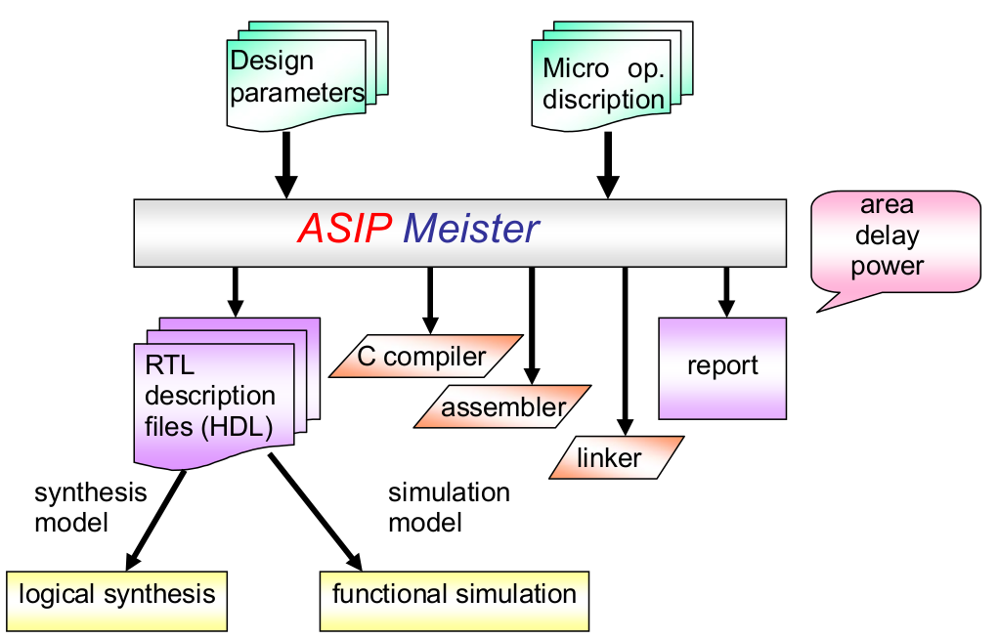

Figure ‎4‑1: ASIP Meister Input and Output

For the above functionality, it is possible to examine and compare different architecture implementations using ASIP Meister. The input/output of ASIP Meister is roughly shown in the figure below. Using the GUI of ASIP Meister, the user inputs the design parameters and Micro Op. description. ASIP Meister generates an estimation report of the processor design quality and its RTL description files. Furthermore, ASIP Meister also generates a development environment composed of a C compiler, assembler and linker. The synthesis model and the simulation model are automatically generated in HDL. These models then become the input to logical synthesis tools and functional simulation tools.

## Processor Design Flow Using ASIP Meister

Open each sub-window in ASIP Meister, in the order specified in Figure 4-2. This would be typically the order of operation that should be performed to design and generate a processor core using ASIP Meister.

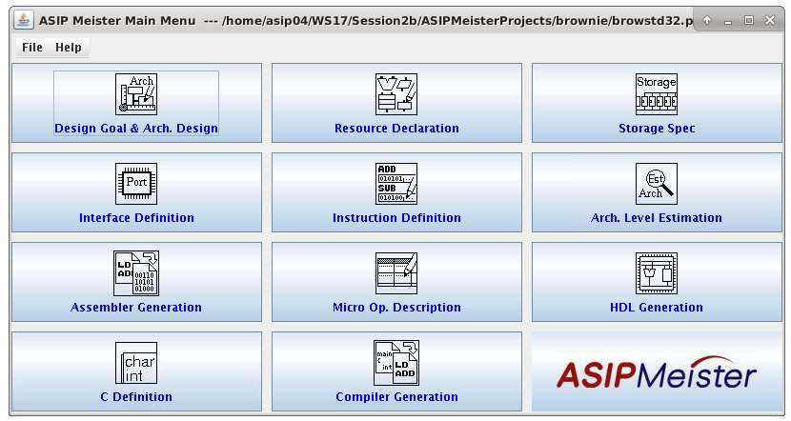

Figure ‎4‑2: ASIPmeister main window

1. **Design Goal & Arch. Design**: Setting design goal values and pipeline stages

2. **Resource Declaration**: Declaring resources

3. **Storage Specification**: Definition Specifying storages

4. **Interface Definition**: Defining I/O interfaces of the target processor

5. **Instruction Definition**: Defining instruction types and instruction set

6. **Arch. Level Estimation**: Estimating design quality of target processor

7. **Assembler Generation**: Generating Assembler description files

8. **Micro Op. Description**: Describing micro-operations for each instruction

9. **HDL Generation**: Generating HDL files of target processor

10. **C Definition**: Defining C code

11. **Compiler Generation**: Generating compiler and Binutils

For details of the individual sub-windows, see the corresponding sections in [TUT] and [UM].

## Typical Challenges while Working with ASIP Meister

* The **register r0** is hardwired to zero in our ASIP Meister CPU. Nevertheless, this is only a hint for the compiler. The compiler will never try to write a value different from zero to this register and the compiler will use this register when a zero value is needed. However, this register can be written with any value, like all the other registers. The reason for this behavior is that the register file is created by the FHM description (flexible hardware model) in the “*Resource Declaration*”, and the configurations in the “*Storage Specifications*” are only used for the compiler and assembler, but are not used for creating the hardware.
* Do not use the “meister/xxx.sim” directory like “browstd32.sim”, when simulating or synthesizing the VHDL code. There is a problem with the register file. Instead, use the “meister/xxx.syn” directory like “browstd32.syn”. The same VHDL-code will be used for synthesis as explained in Chapter ‎6.
* ASIP Meister can only be used once on each computer. Therefore, if two different groups want to work with ASIP Meister, they have to use different computers. To make sure, that ASIP Meister is at most started once on each PC, the starting script tests, whether the file “**/tmp/fhm_server.log**” exists in the temporary directory. ASIP Meister creates this file while starting and it is removed after ASIP Meister terminates. If this file exists, then someone else might already use ASIP Meister on that PC. However, it can also happen, that this file is not automatically deleted, after ASIP Meister terminates. If you think, that no one else is using ASIP Meister on this PC, then remove this file.
* When writing **MicroOp** code, be careful with macros. A macro that is defined as three stage long and started in the ID phase will execute in the ID, the EX and the MEM phases, not just in the ID phase. If you want to view an instruction’s *MicroOp* code without macros, select this instruction and hit the “*Macro Expansion*” button in the upper right corner.

## Tutorial for the “Flexible Hardware Model” (FHM)

To add a new instruction to an ASIP Meister CPU one would usually write a *MicroOp* description for the instruction, using the facilities of an existing hardware module (ALU, shifter, adder, etc.) The ability to use multiple hardware modules during one stage and to create more than one instance of a specific module combined with the operators provided by the *MicroOp* description language is sufficient for most basic instructions. However, this method has several shortcomings that make it impossible to do the following (among others):

* Working with not program-defined wire ranges which depend on register contents or immediate values
* Implementing multi-cycle instructions

This tutorial will show how to write a new hardware module to provide a "*rotate left*" instruction.

### Setting up ASIP Meister to add new FHM

In our current setup, ASIP Meister is installed globally. To modify FHMs you will need to set it up locally:

1. Copy the ASIP Meister directory tree to your home directory:

cp -r /AM/ASIPmeister// ~

1. Update the PATH environment variable to use the local ASIP Meister directory by editing the file ~/.bashrc.user and adding the following line at the end of the file:

PATH=$HOME/ASIPmeister/bin/:$PATH

1. Force the shell to re-read the bashrc file to use the updated PATH variable:

source ~/.bashrc or logout and login again

1. Verify that you are using the correct ASIP Meister copy: “which ASIPmeister” should print the path to the local copy
2. Edit ~/ASIPmeister/bin/ASIPmeister (line 25) and make sure your local ASIP Meister path ($HOME/ASIPmeister) is assigned to the variable ASIP_MEISTER_HOME.

From now on whenever relative paths (not starting with a /) are mentioned, $HOME/ASIPmeister should be the base directory, i.e.: share/­fhmdb/­workdb/­peas/­rotator.fhm should be /home/­asipXX/­ASIPmeister/­share/­fhmdb/­workdb/­peas/­rotator.fhm

### FHM structure

The directory share/fhmdb has two subdirectories and the file fhmdbstruct. ASIP Meister reads this file to determine which FHM files to use. Most of the modules necessary for the basic functions of the CPU are in the directory basicfhmdb; they are further divided into the categories computational and storage. New FHMs should be added to the share/­fhmdb/­workdb/­peas directory.

FHMs are written in XML (eXtensible Markup Language). ASIP Meister processes their data in several stages, most importantly “*HDL Generation”* which creates the CPU VHDL files. Usually some embedded Perl is used in the FHMs to customize VHDL code. An FHM can be divided roughly into two parts: *behavior* and *synthesis*. We are not going to differ between them, though.

**Header and Function description**

First, we need to make ASIP Meister aware of our new FHM. Edit share/­fhmdb/­fhmdbstruct. Go to the tag <library name="workdb"> and add another model to the peas class by adding the line <model>rotator</model>. Save and close the file, as this is the only change needed for this file.

To make your task a bit easier, we have prepared a template file with many mandatory sections already done. Copy the file share/fhmdb/workdb/peas/skeleton-1p.fhm to share/fhmdb/workdb/peas/rotator.fhm and edit this file. TAKE CARE: Small errors in this file will lead to very general error messages that are hard to find. Consider the general hint in Chapter ‎4.6 and double-check your changes for typing errors and missing spaces.

Name your FHM “*rotator*” by editing the name in the <model_name> tag. Rename the author in the <author> tag. The <parameter> section is used to allow FHM customization from the *Resource declaration* section in ASIP Meister. The parameter bit_width for the input and output vector is already defined. Leave it as it is.

Next, we have the *function description*, which is generated with an embedded Perl script. Functions are used by ASIP Meister to interface the MicroOp description and the actual VHDL code. The program generates the necessary registers/multiplexers and control signals to address the corresponding hardware module. The Perl script uses the Perl *print* function to output the *function description*. The << and the following string start a so called “*here document”*, which instructs the Perl interpreter to treat all the following lines as single character string (performing variable substitution) until it finds the string after the << on a single line.

Rename the name of the *function* from "*foo*" to "*rotl*" and change the comment in the line above to something sensible (e.g. "*rotate left*").

Functions are divided into 4 blocks:

**input:** declaration of *function parameters*. We need the actual data and the amount by which to rotate, so write the following two lines between the curly braces of *input*:

bit [$msb:0] data_in;

bit [7:0] amount;

Note that *$msb* is a Perl variable that will be substituted by the actual value (assigned above, *$bit_width - 1*)

**output:** declaration of the *function output*. The rotated value is of the same type as the input value, so add the following between the braces of the *output* block:

bit [$msb:0] data_out;

**control:** *control variables* used by the RTG controller of the CPU. These signals are not accessible from the MicroOp description, but can be used in the VHDL code in the FHM. For our hardware to know which direction (left or right) to shift, we will use a 1 bit signal ('0' for left, '1' for right). Add the following for the *control* section:

in direction;

The in keyword means that the module will be able to access the signal read-only. *out* and *inout* are the other two possibilities.

**protocol:** Describes what the *function* should do once a condition is met. In this case, we will use the following simple protocol:

[direction == '0'] {

valid data_out;

}

That is, it is for the *function description*. The *function convention* is next. The content is identical to the *function description* except for the following two changes:

Write the following into the *protocol* block:

single_cycle_protocol {

direction = '0';

}

Write the following into the *control* block:

in bit direction;

To declare additional *functions*, simply add their descriptions to the “*here document*” (or use a new print statement), do not start a new XML <function_description> or <function_conv> block.

**Ports, Instance and Entity**

The <function_port> section declares the signals that will be connected to our module. As with the *function convention* and *function description* it is an embedded Perl script, and as before the output is done with the “*here document”*. We mentioned all the needed ports in the *function convention* and *description* already: *direction*, *data_in*, *amount*, *data_out*. Use the following lines for the declaration (make sure you write them between the “print <<FHM_DL_PORTS;” and the “FHM_DL_PORTS lines” in the <function_port> part):

direction in bit mode

data_in in bit_vector $msb 0 data

amount in bit_vector 7 0 data

data_out out bit_vector $msb 0 data

You will notice two things: First, there are two types of ports: mode and data ports[1] - use *data* for your input and output signals and *mode* for control signals. Second, one bit signals are declared as bit and don't have a range specification, while signals wider than one bit (vectors) are of type *bit_vector* and have a range (width) - in this case from the most significant bit down to 0.

The <instance> is the core of the module - the actual architecture VHDL code. Embedded Perl is used here as well. Go to the *$signals* variable. As you can see here, documents can also be used to assign values to variables. No additional signals are necessary for our rotator, so we will leave *$signals* as it is.

The next variable, *$vhdl* is more interesting: Our module should be sensitive to changes of input data, shifting amount and shifting direction (so it should re-compute the output data if one of these three values changes), hence we define a process with these three values in its sensitivity list. We also need one integer variable to hold the value of the shifting amount (*amount* is a signal, not a variable) and one signal for the temporary value of the result. After the *begin* keyword we can write the process code. Remember that this variable (as all the others) will later be used to create the actual VHDL output (the variable is not placed at the correct position for the VHDL output, but instead it is later used at the correct position). If you are writing statements that span multiple lines you have to encapsulate them with double quotes (“”) to assign them to the variable.

First, we need to convert the signal *amount* to integer and assign it to *a*. Next we check if *a* is within range, if it is not, we set the result to *undefined*, otherwise we can rotate. A case switch is used to decide into which direction to rotate. The *others* case is necessary, as the type *std_logic* has more states than just '0' and '1', so don't delete it when you add the code for "rotate right".

At the end of the process, we assign the value of the *res* signal to the *data_out* signal. See below listing for the architecture VHDL:

process (data_in, amount, direction)

variable a : integer;

variable res : std_logic_vector($msb downto 0);

begin

a := TO_INTEGER(UNSIGNED(amount));

if (a > 0 and a < $bit_width) then

case direction is

when '0' => -- rotate left

res($msb downto a) :=

data_in($msb - a downto 0);

res(a - 1 downto 0) :=

data_in($msb downto $bit_width - a);

when others => -- not reached

res := (others => 'X');

end case;

else

res := (others => 'X');

end if;

data_out <= res;

end process;

Leave the comment section untouched and look closer at the FHM_DL_TOP_2 document. First, three libraries are included - these are necessary for the std_logic data types and several functions and macros. Next, the entity is declared, which states all input and output ports of our VHDL module. Although we already defined the ports of our FHM, these were interpreted by ASIP Meister - the port declaration for the entity, as well as the rest of the VHDL code will be used verbatim, without any error checking by ASIP Meister (although we can still check for errors in ModelSim). Use the code in the below listing (between the “print <<FHM_DL_PORTS;” and the “FHM_DL_PORTS lines” in the <instance> part) for the entity ports:

data_in : in std_logic_vector($msb downto 0);

direction : in std_logic;

amount : in std_logic_vector(7 downto 0);

data_out : out std_logic_vector($msb downto 0)

That is for the <instance> block. Next, we have an <entity> section. It defines an *entity* in a different file, which is why a new block is needed, but the ports are the same, so use the code from the above listing.

### Estimation and the Synthesis Model

The <testvector> section may be left empty, the <synthesis> script contains instructions to process the FHM file - we leave that untouched as well.

The <estimation> block has data relevant for area, power and delay estimations, but we use more accurate tools, that consider the actual application execution, as shown in Chapter ‎6.5, and Chapter ‎7.2. Leave the estimation data there though, as ASIP Meister will complain without them. You should change FHM parameters however, you will have to adjust the estimation section if you want to get rid of the warnings.

That is it for the *behavior* model. As mentioned in the beginning, we won't differ between the *behavior* and the *synthesis* model, so just copy-and-paste the complete <model> block and change the value of the <design_level> tag from behavior to synthesis.

Your FHM file should now have a structure similar to the following listing:

<?xml version="1.0" encoding="Shift_JIS" ?>

<FHM>

<model_name> rotator </model_name>

<model>

<design_level> behavior </design_level>

[...]

</model>

<model>

<design_level> synthesis </design_level>

[...]

</model>

</FHM>

You can now use the module in ASIP Meister. Instantiate the FHM resource in the *Resource Declaration* and write the new instruction *rotl*. Set the operands to the correct Addressing Mode, DataType, etc in the *Behavior Description* window, but leave the behavior description itself out. Use the syntax

result = ROT0.rotl(source0, am);

where *result* and *source0* are 32-bit wires and *am* is a 8-bit wire.

### Testing the new FHM

When HDL and SWDev Generation run without errors (SWDev will probably print some warnings about setting throughput to 1 - that is alright), proceed testing your module/instruction. Write a small assembly code, compile it (as shown in Figure 2-2), create a new project in ModelSim, load your design and compile it. If there are errors during compilation of the VHDL files (especially in *fhm_rotator_w32.vhd)*, then you have made a mistake in your VHDL code. Now you could go back to the FHM and correct it there, but a faster way is to edit the mentioned VHDL file in your ~/ASIPMeisterProjects/­browstd32_YourCPU/­meister/­browstd32_YourCPU.syn/ directory and try to correct the code there. Once you get it running, make the corrections in the FHM file as well (important: in the behavior and synthesis sections), as ASIP Meister will overwrite the VHDL files every time you recreate the CPU.

Once your CPU VHDL files are compiled, run your test program. Check the results carefully! Experiment with large values as well (i.e. use lhi %r2, $65535 to set the upper 16 bits to '1'). Once you verified your design, backup your FHM (important!) and implement the “rotr “ - right rotation instruction by making the necessary changes to your FHM.

## Multi Cycle FHMs

As mentioned at the beginning of the tutorial, one of the reasons to write custom FHMs is to implement multi-cycle (stalling) instructions. Examples of stalling instructions are the multiplication and division operations, which use dedicated multiplier and divider hardware blocks. Stalling hardware is usually implemented with *State Machines*. This section will show you how to write a FHM for a multi-cycle instruction. We will extend the rotator from the previous sections - the multi-cycle version will rotate only one bit per cycle (obviously the performance will be inferior to the single-cycle variant; it is just for demonstration).

ASIP Meister provides three signals to control multi-cycle instructions: *start*, *fin* and *cancel*. The *start* signal will be set by the RTG controller once the instruction is started, and our hardware will set the *fin* signal once the operation is finished, to signal the CPU that normal pipeline operation can be resumed. If a *cancel* signal arrives, the hardware should abort its operation. We will disregard the cancel signal here, but reset our hardware on the CPU *reset* signal into its default state.

**<function_description>**

We need to define the three control signals in the *control* block of our function. As the *control* block of your function use

in start, cancel, direction;

out fin;

We also need a protocol for our stalling instruction. For the *protocol* block use:

repeat [start == 1] until (fin == 1 || cancel == 1);

if (fin == 1 && direction == 0) {

valid data_out;

}

**<function_conv>**

Add the three signals to the *control* block of your function. It should be now:

in bit direction;

in bit start;

in bit cancel;

out bit fin;

and for the *protocol* block use:

multi_cycle_protocol {

start_signal start = '1';

fin_signal fin = '1';

cancel_signal cancel = '1';

direction = '0';

}

**<function_port>**

The three signals as well as the CPU *clock* and *reset* signals need to be added to the port declaration of our FHM, so use:

direction in bit mode

data_in in bit_vector $msb 0 data

amount in bit_vector 7 0 data

data_out out bit_vector $msb 0 data

clock in bit clock

reset in bit reset

start in bit ctrl

fin out bit ctrl

cancel in bit ctrl

Note that the port type is *ctrl*, not *mode* for the three multi-cycle control signals, and *clock* and *reset* for the two CPU signals respectively.

**<instance>**

The VHDL implementation uses one process for the state machine, but this time we only use *clock* and *reset* in its sensitivity list. In the process body, we first handle the reset case (synchronously), and then depending on the current state we either start the state machine from the idle state (st0), execute a one-bit rotation (st1), or assign the result (st2). The following code is provided as text file as well:

$vhdl = "process (clock, reset)

type t_s is (st0, st1, st2);

variable state : t_s;

variable a : integer;

variable res : std_logic_vector($W1 downto 0);

variable tmp_data : std_logic_vector(31 downto 0);

begin

if rising_edge(clock) then

-- handle reset (synchronous)

if reset = '1' then

state := st0;

data_out <= \"00000000000000000000000000000000\";

fin <= '1';

else

case state is

when st0 =>

if start = '1' then

state := st1;

a := TO_INTEGER(UNSIGNED(amount));

tmp_data := data_in;

end if;

fin <= '0';

when st1 =>

if (a > 0 and a < $bit_width) then

case direction is

when '0' => -- rotate left one bit

res($W1 downto 1) := tmp_data($W1 - 1 downto 0);

res(0) := tmp_data($W1);

when others => -- not reached

res := (others => 'X');

end case;

a := a - 1;

tmp_data := res;

else

if a /= 0 then

res := (others => 'X');

end if;

state := st2;

end if;

fin <= '0';

when st2 =>

data_out <= res;

state := st0;

fin <= '1';

end case;

end if;

end if;

end process;";

Further down, in the *entity* declaration, we will need to add our three control signals as well as the clock and reset signals. The entity should now have the following signals:

data_in : in std_logic_vector($W1 downto 0);

direction : in std_logic;

amount : in std_logic_vector(7 downto 0);

data_out : out std_logic_vector($W1 downto 0);

clock : in std_logic;

reset : in std_logic;

start : in std_logic;

cancel : in std_logic;

fin : out std_logic);

**<entity>**

Again, our five signals need to be added to the *entity* declaration. The new *entity* should have:

data_in : in std_logic_vector($W1 downto 0);

direction : in std_logic;

amount : in std_logic_vector(7 downto 0);

data_out : out std_logic_vector($W1 downto 0);

clock : in std_logic;

reset : in std_logic;

start : in std_logic;

cancel : in std_logic;

fin : out std_logic);

### Estimation, Synthesis, ASIP Meister usage and Testing

No changes for estimation or synthesis but make sure to copy your changes to the behavior <model> section of the FHM.

Instantiate and use the resource in ASIP Meister just as with a singly-cycle FHM - no changes needed. Write a test program and check in ModelSim whether the pipeline actually stalls (the *im_addr* value shouldn't change during stalling) and whether the result is the same as with the single-cycle instruction.

## General Hints about FHMs

* Do not copy and paste the code from this pdf file. Often, this manifests in wrong code (e.g. wrong blanks) and the effort to debug the code afterwards is bigger, than manually transcribing the code.
* ASIP Meister has only very few debug facilities for FHMs (e.g. /tmp/fhm_server.log contains some more information compared to the popup windows). Therefore, you usually have to use the trial and error scheme. The syntax for FHMs is very restrictive. Sometimes a missing blank can cause a problem. Sometimes (!) you can ignore error messages in the *Resource Declaration*, as long as the resource was successfully instantiated. These error messages are meant for the *Estimation,* which is not needed for the implementation.
* The FHM example in this tutorial is constructed for a module with one parameter. When you need more parameters, have a look at the other existing FHMs.
* As soon as a new FHM is successfully constructed, you can make further changes directly in the VHDL code for simplicity. Whenever the VHDL code is finalized, you should include it into the FHM file again, as the created VHDL files are overwritten every time you regenerate your CPU.
* Create backups very frequently. Due to the difficult debugging, it is difficult to find and fix bugs and thus it is often simpler to go back to a slightly earlier version and to implement the changes again.

## Synthesizable VHDL code

Here are some hints for improving the chance, that your code is synthesizable. These are not general statements that are true under all circumstances or that guarantee that your code will be synthesizable.

* VHDL procedures often make problems for synthesizing (aborting with error message). Avoid them unless you know what you do.
* Within a process only use the ’event modifier once, e.g. if clk=’1’ and clk’event.
* Avoid wait statements.
* Avoid the data types ‘bit’ and ‘bit_vector’, but use ‘std_logic’ and ‘std_logic_vector’ instead.
* Typically everything inside a process should be synchronous, e.g.:

MyProcess : process (clk)

begin

if rising_edge(clk) then

-- rising_edge(clk) is a macro for clk'event and clk='1'

if reset = '1' then

...

else

...

end if;

end if;

end process;

* Initialize all signals/variables in the reset statement. The initialize-statement (e.g. “variable foo : integer := 42;”) is either ignored or only evaluated when the FPGA is configured, but certainly it is not evaluated when you press the reset button.
* In VHDL simulation, the output of a process is only recomputed, if any signal in the sensitivity list had an activity/event. In hardware, the processes run all the time, as they are implemented in dedicated hardware. This can lead to correct simulation results that are not reproducible in the FPGA prototype. Therefore, the sensitivity list is only meant for simulation and has no impact to the synthesis. If everything inside your process is synchronous (like in the above example), then the clk is the only signal you need in your sensitivity list. Otherwise, all signals that are read need to be considered in this list!
* Often a final state machine (FSM) is needed. Below is an example for it. A different approach that also supports VHDL procedures can be found in [FSM].

MyStateMachine : process(clk)

type stateType is (state0, state1);

variable state : stateType;

begin

if rising_edge(clk) then

if reset = '1' then

state := state0;

else

case state is

when state0 =>

...

when state1 =>

...

when others =>

...

end case;

end if;

end if;

end process;

# ModelSim

ModelSim is a full-featured VHDL simulator. With VHDL, you can create logic designs consisting of any size. To verify functional operation you need to simulate your design to see whether it works like expected. Therefore, test benches are used. They contain so-called stimuli or test vectors, simply said: values for the input signals. These values are applied to the input signals and then the corresponding output signals are compared with the expected values.

To simulate a specific design one has to provide two kinds of files to the ModelSim simulator: VHDL files that contain your processor design and a testbench file that creates the needed environment. ASIP Meister creates the VHDL files for your processor design automatically and the designer does not have to take care about the VHDL implementation of the processor. We provide the testbench and you can find it in the TEM­PLATE_­PRO­JECT/ModelSim directory (directory structure is explained in Chapter ‎2.2.2). This testbench generates a reset and a clock signal to the CPU. Furthermore, it contains simulated data- and instruction-memory for the CPU. These simulated memories have to be initialized with memory images that are read from TestData.DM and TestData.IM, before the CPU can start executing the application. The Makefile script creates these memory images automatically during “make sim” or “make dlxsim” and are copied to the ModelSim directory of your current ASIP Meister project (so you are always simulating the last application that was compiled). After the simulation of the application is finished, you will find a memory image of the final data memory TestData.OUT that contains the results of the application if they are stored in data memory.

## Tutorial

### Create a new ModelSim Project

Please be aware that it is important that you start ModelSim in the ModelSim directory of your ASIP Meister project, as shown in Chapter ‎2.2.2.

On the shell change to the ModelSim directory of your project and invoke “vsim &”. If ModelSim asks for “modelsim.ini” choose the default one like “/Software/ModelSim/ModelSim_6.6d/modeltech/modelsim.ini”

Menu: File > New > Project

Enter a project name e.g. dlx_basis1 and change the project location to the ModelSim directory in your project directory. Confirm the dialog with the OK button.

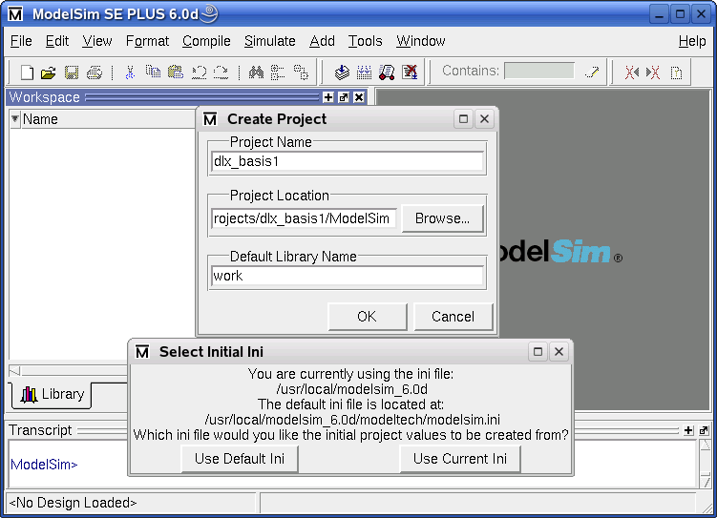

Figure ‎5‑1: Creating a ModelSim Project

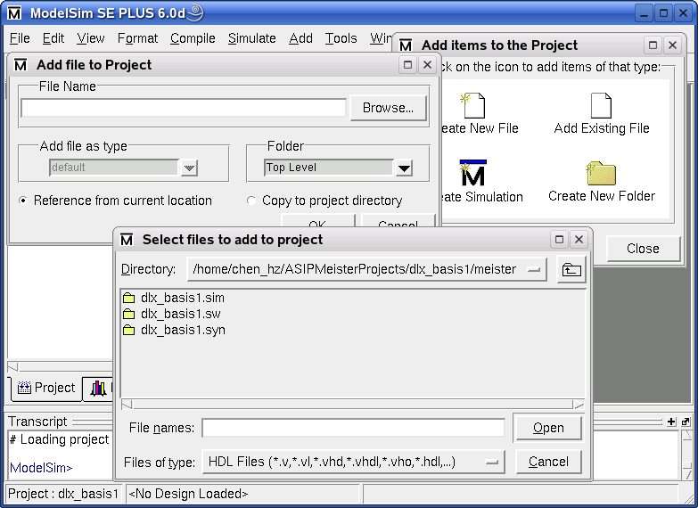

Figure ‎5‑2: Adding Files to a ModelSim Project

### Adding the Testbench and ASIP Meister CPU files

Choose the icon “Add Existing File”. Browse to the VHDL netlist files for the processor e.g. “meister/ dlx_basis1.syn” directory of your ASIP Meister project. Here you will find the VHDL files for synthesis. There is also a VHDL model of the processor in the .sim directory, but do not use the files of the .sim directory, as they do not work properly. Select all the files and confirm the dialog with “open”. Once again, choose the icon “Add Existing File” to add the testbench files: tb_browstd32.vhd, MemoryMapperTypes.vhd, MemoryMapper.vhd, and Helper.vhd from the ModelSim directory of your current project.

### Compile the project

Menu: Compile > Compile Order > Auto Generate

Every file is compiled and you can see the result of the compile process. ModelSim determines automatically the compile order of the VHDL files. After closing the dialog every file should have a green mark before its name, showing that the compilation was successful (instead of the question marks), shown in Figure 5-4. A green mark with a yellow dot is a warning that usually indicates a problem. So take care about the warnings.

**IMPORTANT**: When you edit your CPU in ASIP Meister and execute HDL Generation, then the VHDL files are regenerated and have to be recompiled. ASIP Meister might even generate new files, that have not been there in the previous set of VHDL files, e.g. for new pipeline registers that are needed for modified MicroOp Descriptions. These new VHDL files are not included into your ModelSim project yet. Also previously needed VHDL files might no longer be needed for a modified ASIP Meister CPU and ModelSim will complain about these files while recompiling. To avoid manually checking every VHDL file, whether it already was included into your project or whether it is a new file, you can do the following: Delete the meister/dlx_basis1.syn directory before executing the HDL Generation; this will make sure that no files that are no longer needed exist. Remove all ASIP Meister VHDL files out of your ModelSim project and after executing the HDL Generation just add the newly created VHDL files from the meister/dlx_basis1.syn directory, like explained in the previous paragraph. Instead of the sub window shown in Figure 5-2, when creating a new project, you can use the menu: File > Add to Project > Existing File.

### Run the simulation

Menu: Simulate > Start Simulation

Open the work library, mark the entry cfg (that is the VHDL configuration for the testbench) in the list (as shown in Figure 5-4) and press OK. That will start the simulation and you will get some other window like “Objects”, “Processes”, “Wave” and a “sim” tab attached to the Workspace.

IMPORTANT: Make sure that no Component Unbound Message is printed while starting the simulation. If such a message is printed, then this is a serious problem within the simulation. Usually it helps to recompile everything and to start the simulation again (menu: Compile > Compile All). However, a new VHDL file, that was automatically created by ASIP Meister, but that is not included into your project yet, can also cause such a message.

Menu: Tools > Tcl > Execute Macro…

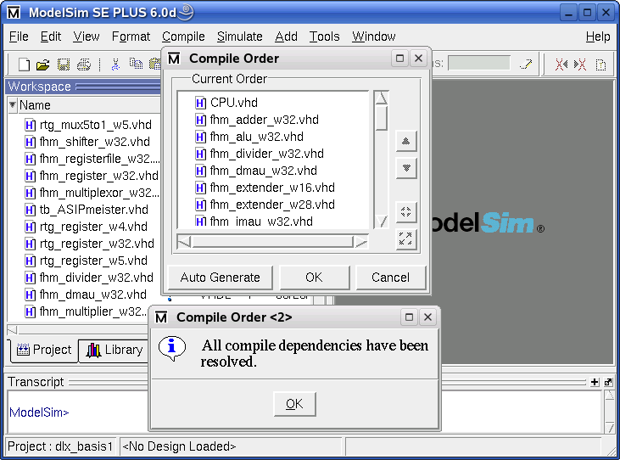

Figure ‎5‑3: Compiling the Project

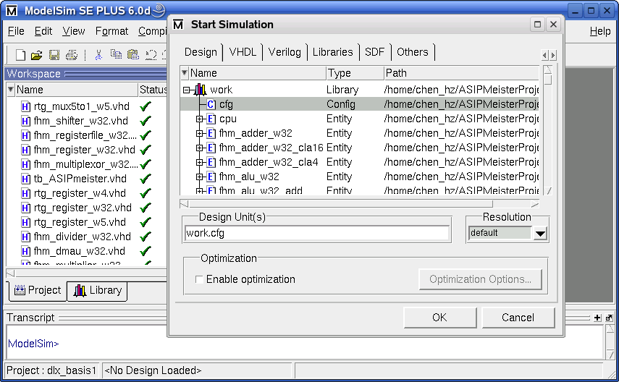

Figure ‎5‑4: Starting the ModelSim Simulation

Select the wave_vhdl.do file in your ModelSim directory and press OK to load it. The wave-window will be filled with certain signals that are useful to evaluate the simulation of the program running on the processor. These signals are explained in Chapter ‎5.1.5.

Press the button Run all to run the simulation until it aborts. At the end of a simulation the message “Failure: Simulation End” is printed. The type “Failure” is only used to automatically abort the simulation. This is not a real failure. At the simulation end, the file TestData.OUT is created in your ModelSim directory. It contains the content of the simulated memory after the CPU finished working. Therefore, if your algorithm is storing the result in the memory you can find the values here.

If you want to run another simulation with a modified program or with a modified initial data memory on the same CPU, then execute again “make sim” in the respective application subdirectory to create the new TestData.IM and TestData.DM and afterwards you have to press the buttons restart and run all, like shown in Figure 5-5.

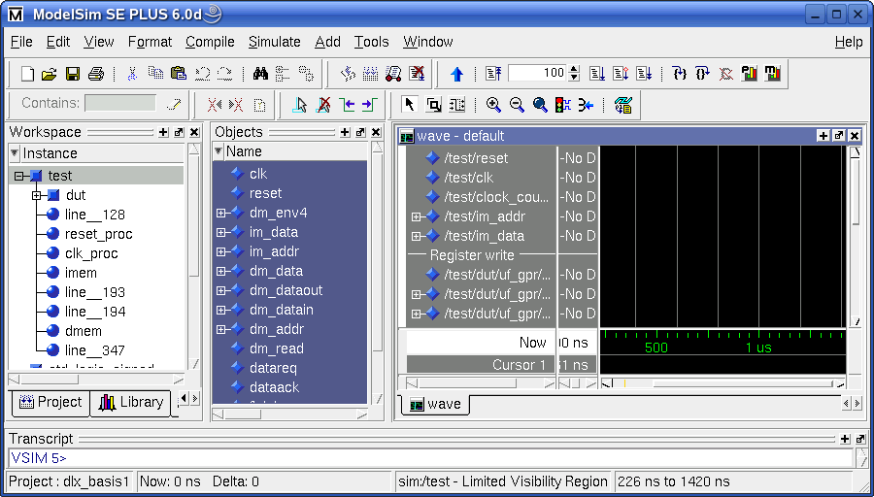

Restart Simulation

Run Simulation for a configurable amount of time

Run all time

Figure ‎5‑5: Running the ModelSim Simulation

### Statistics of the Simulation

During simulation time, the testbench prints status messages about memory access (Load/Store operations) into the workspace status window. Thus, you can see which operation is being executed and which values are being stored and loaded. The following examples show a read and a write access:

# ClockCycle:23 InstrAddr:0x00000042 DMemAddr:0x0000FFF0 --> 0 (Read)

# ClockCycle:30 InstrAddr:0x00000049 DMemAddr:0x0000FFF4 <-- 0 (Write 32-Bit) (Old value was 45)

The read access is performed in cycle 23 while the currently requested instruction memory address (IM_addr_out) is 0x42. This does not mean, that the corresponding load instruction is fetched into the pipeline in cycle 23 or that this load instruction is placed at IM_addr_out 0x42. Instead, this means that the MEM-Phase of the corresponding load instruction is executed in cycle 23 and that the instruction at address 0x42 is fetched into the pipeline, while this load instruction is performing its MEM phase. The corresponding load instruction is usually placed some instructions before the printed IM_addr_out, unless there was a jump in between. The loaded value is zero in the printed example and this value comes from address 0xFFF0. This is a stack operation, as the stack is starting at address 0xFFFF and growing downwards in our case (but the starting address of the stack might be a subject of changes). The loaded value is zero in this example. The afterwards printed write-example additionally shows which value is placed in the memory location that is to be overwritten.

A more detailed kind of statistics for the simulation is the wave diagram as shown in Figure 5-6. The waves show the internal details of the VHDL model that is simulated. The waves are grouped into five parts, which are explained in Figure ‎5‑7:. For more details of the memory signals, see Page-47 in [RM].

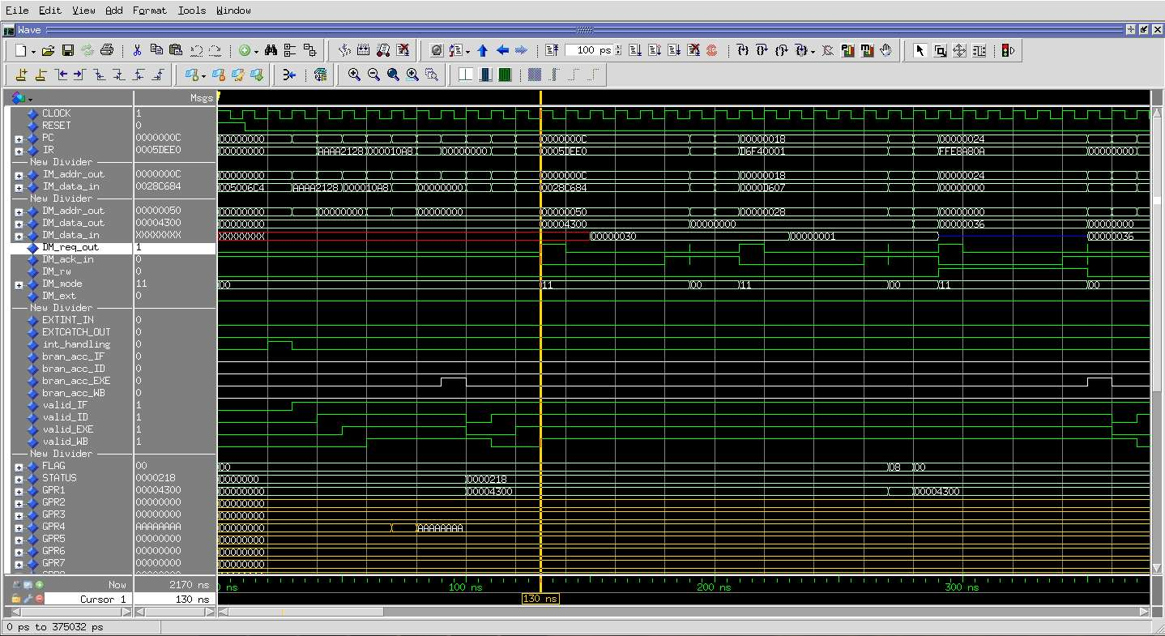

Figure ‎5‑6: ModelSim Waveforms

To add additional signal to the Wave window (which is very helpful for debugging) you need to enable two views in ModelSim (both are enabled by default):

Menu: View > Workspace

Menu: View > Debug Windows > Objects

| **Signal** | **Explanation** |
| --- | --- |
| RESET | The reset signal of the CPU. This signal is active at the beginning of every simulation to initialize the CPU. |
| CLOCK | The clock signal of the CPU. This signal is helpful to see, when other signal changes are really taken into the CPU, as they are only sampled at the rising edge of the clock. |
| PC | Program counter |
| IR | Instruction register |
| clock_counter | The clock counter counts the number of executed clock cycles since the CPU started running after the initial reset. |
| IM_addr_out | This is the Instruction Memory Address. It shows the address of the instruction that the CPU wants to fetch into its pipeline. |
| IM_data_in | This is the Instruction Memory Data that corresponds to the previous shown im_addr. Therefore, it is the binary representation of the assembly instruction that is fetched by the CPU. |
| DM_addr_out | This is the Address Bus for memory accesses. This bus either contains the address to which some data will be written or the address from which some data will be read. |
| DM_data_out | The Data Bus contains the value that will be written to the memory. |
| DM_data_in | The Data Bus contains the value that will be read from the memory. |
| DM_req_out | This is the request signal from CPU to trigger a read or a write access. |
| DM_ack_in | This is the acknowledge signal, that is activated by the memory controller after a requested write access is finished or after the data bus contains the result of a requested read access. |
| DM_rw | Read from the memory if 0, otherwise write to the memory. |
| DM_mode | This signal determines the read/write mode. The usual values are “11” for “word” and “00” for “byte” read/write. |
| DM_ext | Sign extension signal |
| EXTINT_IN  EXTCATCH_OUT  int_handling | Interrupt Signals |
| bran_acc_IF  bran_acc_ID  bran_acc_EXE  bran_acc_WB  valid_IF  valid_ID  valid_EXE  valid_WB | Pipeline stages information |
| FLAG  STATUS  GPR1... GPR31 | Register file values |

Figure ‎5‑7: Explanation of the Signals in the ModelSim Waveform

In the “Workspace”, you can choose which instance of your design will be shown in the “Objects” windows. From the Objects window, you can then drag-and-drop signals to the Wave window.

## General Hints

* Change to your ModelSim directory inside your project directory tree and verify that the memory images TestData.IM and TestData.DM are present. The Makefile should have automatically created these files. Furthermore, you need the ModelSim testbench file tb_browstd32.vhd and the configuration script wave_vhdl.do, which are available in the TEMPLATE_PROJECT/ModelSim directory. Please make sure that these files exist in your ModelSim directory before you start the simulation. It keeps you safe from trouble.
* Always invoke ModelSim in the specific ModelSim directory of your current project by executing vsim & in this directory. ModelSim is working with project directories and is searching for information in the directory where it is invoked. After creating new projects all settings will be saved in the project file e.g. projectname.mpf (where mpf stands for ModelSim Project file). To speed up the starting process you can invoke vsim with an option for your project file that you have created in an earlier simulation: “vsim projectname.mpf &”.
* When you compile VHDL files ModelSim creates a local library in the subdirectory work to store the compilation results. This is the main reason why it is important to start ModelSim in the right place. It looks for last project information and for the local library.
* Sometimes you might get compiler errors from the ModelSim VHDL compiler. This is usually not the fault of ASIP Meister or the testbench. Very often, a “recompile all” solves this problem. However, sometimes you will have to create a new project from the scratch to get it working.
* If you open the waves before the simulation is started, then the signals will not be displayed. First start the simulation, and then open the waves.

# Validating the CPU in Prototyping Hardware

In this step, we will test the CPU and application, which were generated in the previous steps, on a FPGA prototyping system. For this purpose, we will use the XUPV5-LX110T Prototyping Board from Xilinx shown in Figure 6-1.

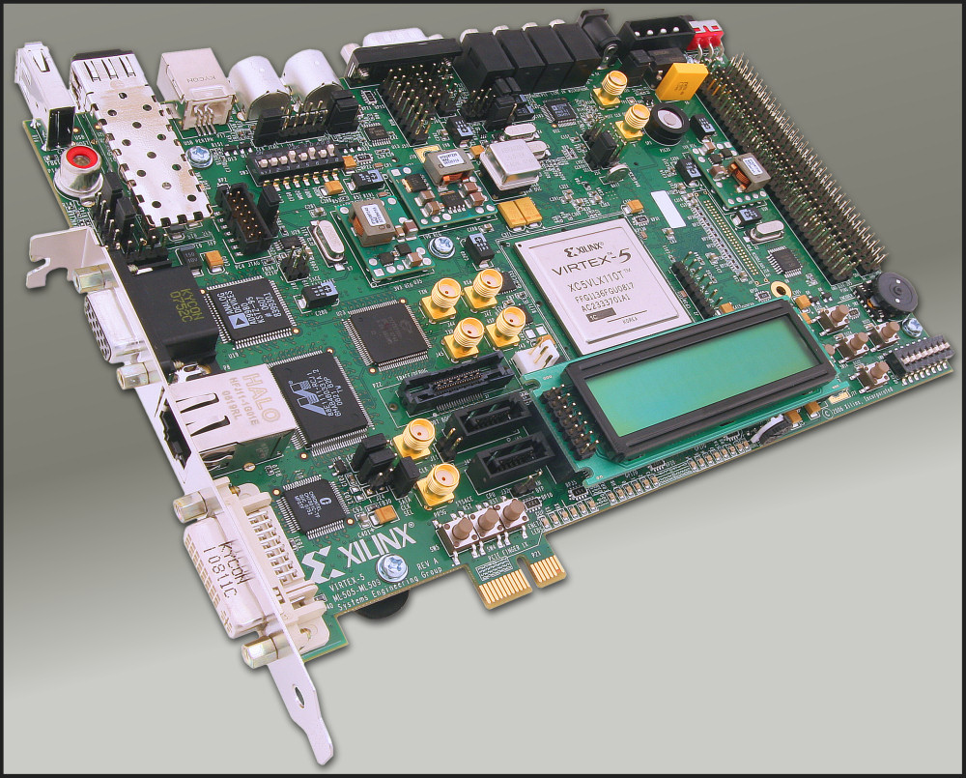

Figure ‎6‑1: XUPV5-LX110T Prototyping Board from Xilinx [HWAFX]

## Creating the ISE Project

ISE (also called Project Navigator) is a program from Xilinx to support the whole tool-flow from managing your source files during synthesis, map, and place & route until finally uploading the design to the FPGA board.

Start ISE by just executing “ise &” in your ASIP project directory

If you do not already have a project for your current CPU, then create a new one: Select *File* Menu > *New Project*. As “Project Path” you should choose your ASIP Meister Project Directory (e.g. “ASIPMeisterProjects/browstd32/”) and as “Project Name” you can choose something like “ISE_Framework”. This “Project Name” will then automatically be added as new subdirectory to your chosen Project Directory. In the upcoming window “Device Properties”, you have to adjust the values to the data shown in Figure 6-2. Afterwards just press Next > Next > Finish to create an empty project for your CPU. The device settings are needed to make sure, that the map, place and route tools know exactly the type of the target FPGA. For example, you will have a project with following project settings:

Project Name: ISE_Framework

Project Path: home/asip04/ASIPMeisterProjects/browstd32/ISE_Framework

Device Family: Virtex5

Device: xc5vlx110t

Package: ff1136

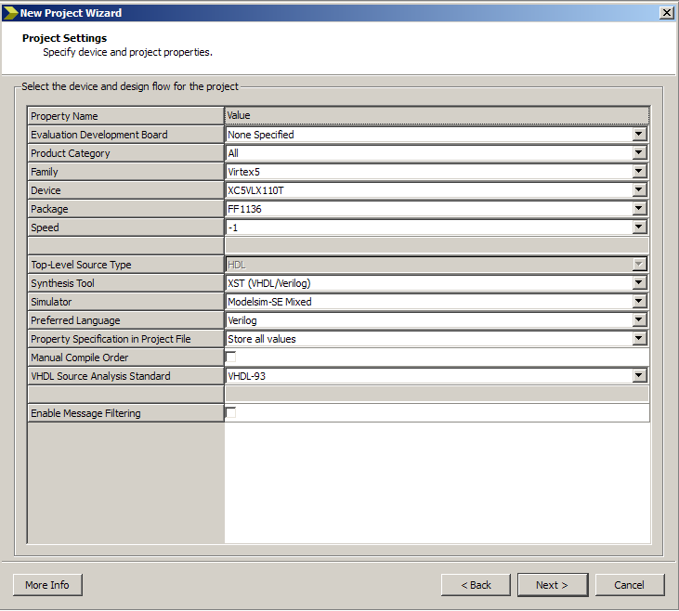

Figure ‎6‑2: ISE Device Properties

## Adding Source Files to ISE Project

Now you have to add the needed VHDL and constraint files to your ISE project, by right clicking on the XC5VLX110T-1ff1136 entry of your Sources View (at the upper left inside your ISE Window, see Figure 6-3 & Figure 6-4) and choosing “Add Copy of Source”. After ISE has analyzed the type of the files, press OK. Adding a copy of the source has the advantage, that you can locally modify the files and that the CPU files in your ISE project are not overwritten, when you modify your ASIP Meister Project for testing purpose.

There are three types of files that are needed for a hardware implementation:

* CPU VHDL Files
* Framework Files
* Framework IP cores

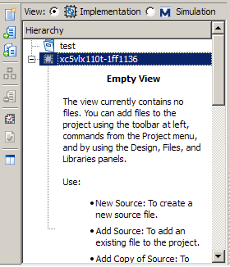

Figure ‎6‑3: Add Sources

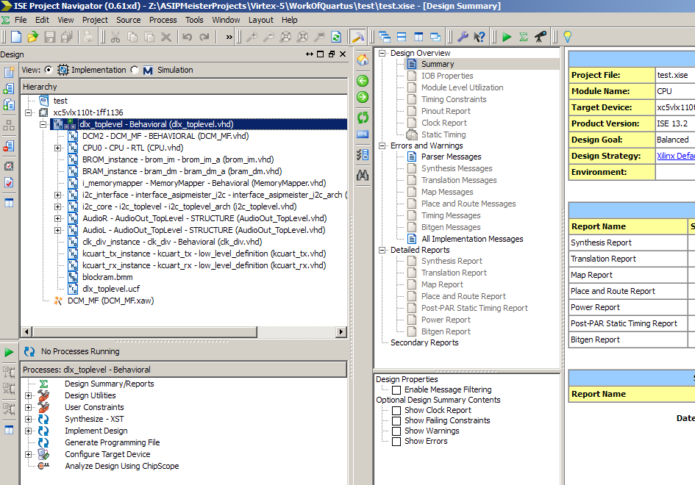

Figure ‎6‑4: ISE Project Overview

**CPU VHDL Files** have been generated using ASIP Meister and they can be found in the meister/{CPU-Name}.syn directory, as explained in Chapter ‎2.2.2.

**Framework Files** are important for the connection between CPU, Memory, UART, and all other components. They are predesigned for this laboratory and they are available in /homeasip00/­ASIPMeisterProjects/­TEMPLATE_PROJECT/­ISE_Framework. The framework consists of the following three types of file and all of them have to be added to the ISE project.

* The VHDL files describe how all components are connected together.
* The UCF file describes the user constraints (e.g., which I/O pins should be used for a signal, which clock frequency is requested etc.).
* The BMM file contains a description of the memory buildup for instruction- and data-memory for the CPU. Out of this file …_bd.bmm file will be generated while implementation and this file is then used to initialize the created bitstream with the application data, as explained in Chapter ‎6.4.

**IP cores** are used within the framework, e.g. memory blocks for instruction- and data-memory or FIFOs for the connection to the LCD. These IP cores are not available as VHDL source code, but instead they are available as pre-synthesized net lists. These files just have to be copied into the directory of your ISE project (no need to actually add them to the project) and then they will be used during the implementation step. The needed files (*.edn, *.ngc) are available in /home/asip00/­ASIPMeisterProjects/­TEMPLATE_PROJECT/­ISE_Framework/­IP_­Cores. Note: The files inside the IP_Cores directory have to be copied to your ISE Project Directory. It is not sufficient to copy the full IP_Cores directory!

After you have added/copied all needed files to your ISE project/directory, your main window should look similar to the screenshot shown in Figure 6-4. In the sources sub window you can see all the source files and how they are structured, i.e. according to the file instantiated by other file.

## Synthesizing and Implementing the ISE Project

In the Processes sub window in the lower left corner of Figure 6-4, the possible actions for each kind of file is shown. To synthesize and to implement your project you have to choose your VHDL-Toplevel in the Sources sub window (“dlx_Toplevel” in the figure) and afterwards you have to double click “Generate Programming File” in the Processes sub window. This will finally create the .bit file that can then be initialized with your CPU instruction- and data-memory and afterwards be uploaded to the FPGA prototyping board.

The whole process of synthesizing and implementing the design is subdivided into several steps that can be seen, if you click on the plus sign in the processes sub window. After the completion of each step, an update of the FPGA Design Summary will be shown in the corresponding sub window in the upper right corner. For example, the device utilization (i.e. the size of your CPU plus the framework) will be shown for the different types of elementary hardware available on the FPGA (e.g. clocks, logic, BRAMs). This is a first hint, how big your CPU actually is, but as it will be explained in Chapter ‎6.5, these values are not completely accurate, as they not only include the CPU, but also include the Framework, which consists of many different components.

While synthesizing and implementing the design, many warnings will be printed. These warnings (unless created by a user modification, e.g. in the CPU) can be ignored. However, it should be mentioned, that it is very helpful to understand the meaning of these warnings when you are looking for a reason why something is working unexpected in hardware. The challenge here is, that the CPU and the IP cores create plenty of warnings, thus it is hard to locate the serious warnings.

## Initializing FPGA Internal Memory with your Application

After you have finished the synthesizing and implementation step, you receive a bitstream of your ISE project that includes your CPU connected to an internal memory inside the FPGA. Now you have to initialize this FPGA internal memory (called Block RAM or BRAM) with your application instruction- and data memory to execute your program on your CPU. This initialization can be done inside the bitstream itself, i.e. before uploading the bitstream to the FPGA board.

To initialize the bitstream with your application, you need your application as TestData.IM and TestData.DM files, created with “make sim” or “make dlxsim” as explained in Chapter ‎2.3. However, compared to simulation with dlxsim or ModelSim you have to consider, that you have a limited amount of memory on the FPGA and therefore you have to adjust the position were the stack starts. For the usual simulation, the stack can start at some address e.g, 0xFFFFC and is growing downwards. For hardware execution, this address is too big. For the current hardware prototype, you should use 0xEFFC. You can adjust the place where the stack will start in the file /home/asip00/epp/mkimg/Makefile by adjusting STACK_START_FPGA variable. This Makefile is accessed from your local application Makefile located in the directory of your application (like /home/asip00/­ASIPMeisterProjects/­TEMPLATE_PROJECT/­Applications/­TestPrint/Makefile) and it is evaluated every time you execute this local Makefile. Here you can configure the address of the stack start. To work in hardware this value depends of the size of the available memory in hardware. For our current prototype, “0xEFFC” is the correct value. In case of FPGA, this parameters is set to STACK_START_FPGA.

After the TestData-files for your application are created (see above and Chapter ‎2.3) and the bitstream of your ISE project is created (see Chapter ‎6.1 and Chapter ‎6.3) you can initialize the bitstream with your application data by executing “make fpga” in your application subdirectory. This script will create two new files in BUILD_SIM subdirectory of your application like DirectoryName.mem and DirectoryName.bit. The .mem file contains a memory dump for data and instruction memory and is only a temporary file. The bit file is the final bitstream of your specific CPU surrounded by the framework, and with your application initialized to the BRAM. You have to configure the ISE project that you want to use in the “env_settings” as “ISE_NAME”. The bitstream in this directory will be used to create the application-initialized bitstream.

### Uploading the Bitstream to FPGA Board

After you have created the final bitstream with the initialized BRAM, you can upload this bitstream to the FPGA Board. At first, you have to turn the FPGA Board on.

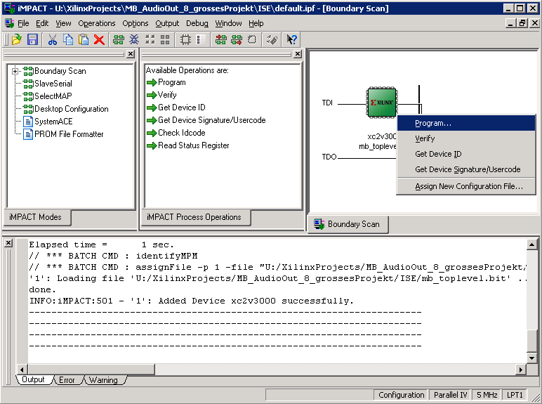

Figure ‎6‑5: Uploading the Bitstream with iMPACT

After the FPGA Board is running, you have to connect the FPGA to the PC and then initialize it with your Bitstream. Therefore, the software iMPACT from Xilinx, shown in Figure 6-5 is used. If you try to start iMPACT you will receive an error message, complaining about the project-/ and the working directory (because you are not an administrator on this PC). Therefore, right-click the symbol and choose “properties”. Then configure the working directory to “U:” (this is your mounted Linux-server home). Afterwards you can start iMPACT. Create a new project (no need to ‘save’ and ‘load’ a project) and choose the default point “Configure Device using Boundary Scan (JTAG)”. You should see a JTAG chain with one device (the FPGA) as shown in Figure 6-5. Assign the bitstream of your application subdirectory (ASIPMeisterProjects/browstd32/Applications/...) to the Xilinx FPGA device. To reactivate this menu point in a later run without restarting iMPACT, just right-click on the Xilinx device and choose “Assign New Configuration File”. To program the Xilinx device (i.e. the FPGA) choose “Program” as shown in Figure 6-5 and confirm the dialog without any changes with “OK”.

Instead of using graphical iMPACT tool for uploading the bitstream to the FPGA, you can use your Makefile “make upload” in your application subdirectory to upload the combined bitstream to the FPGA. This will automatically scan and program the FPGA.

### Initializing and Using the External SRAM

The size of the BlockRAM (i.e. FPGA-internal RAM; at most 192 Kbyte for our FPGA, but something is used in the Framework for FIFOs etc.) is limited. This is especially problematic if a huge amount of input-data is to be used for an application. Therefore, we have provided external SRAM to the Board, altogether four MB SRAM for IM and four MB SRAM for DM respectively. Our provided ISE Framework (see Chapter ‎6.1) provides the connection between the CPU and the SRAM. However, before the SRAM can be used it has to be initialized. Currently the SRAM initialization is unexpected slow. Therefore, whatever you want to test on the FPGA board, test a BlockRAM version first. The provided ISE Framework still provides the connection to the BlockRAM additionally. You just have to follow the above tutorials (Chapter ‎6.4 and ‎6.4.1) but do not forget to configure STACK_START_FPGA in the Makefile to 0xEFFC. To use the SRAM, follow the following tutorial:

* You have to compile the bootloader.c application (you can find it in /home/asip00/­ASIPMeisterProjects/­TEMPLATE_PROJECT/­Applications/­Bootloader/) with “make sim” and initialize the bitstream with the application using “make fpga”. The resulting bit file contains the bootloader application in the FPGA internal BlockRAM.
* You have to compile the user application (i.e. the one that you actually want to run from the SRAM) with the STACK_START_FPGA configured to 0xFFFFC (in the Makefile; instead of 0xEFFC for BRAM). Note that, besides the normal TestData.IM and TestData.DM additionally the files TestData.IM_uart.txt and TestData.DM_uart.txt are also created in the BUILD_SIM subdirectory.
* You have to start the “dlx_uart.ht” file under windows, which will open the MS Windows HyperTerminal with the correct settings (Bits per Second=230400, Data Bits=8, Parity=None, Stop Bit=1, Flow Control=None). You can find “dlx_uart.ht” in /home/asip00/­ASIPMeisterProjects/­TEMPLATE_PROJECT/­Applications/­Bootloader). However, you may have to adapt the configured COM port, depending on which port you are connected to the FPGA (see Figure 6-6). Under, Ubuntu, you can start HyperTerminal by typing “hterm &” and can configure the settings as mentioned before. After that, you have to click the “connect” button to open the connection. Opening the connection always works without error message, but you have to make sure that the FPGA board is connected to the PC where you are running the HyperTerminal via UART.
* Now configure the FPGA Board to run with 40 MHz (see point (9) in Figure 6-6) and upload the bootloader bit-file (created in first step) with iMPACT. The UART port on the FPGA is configured to work with 40 MHz and if you use a faster or slower frequency, then you will not see the correct output via UART. The bootloader will prompt on the UART-Console for initializing the SRAM. It will ask for three things (you have to answer with pressing ‘y’ or ‘n’): Initialize IM, Initialize DM, and Start Application.
* To initialize IM or DM you have to select ‘y’ and then use the HyperTerminal menu “Übertragung” 🡪 “Textdatei senden” to upload the file TestData.IM_uart or TestData.DM_uart.
* If you do not start the application in the IM-SRAM (pressing ‘n’ when asked) OR when the IM-SRAM application is finished OR when you press the reset button THEN you will come back to the bootloader.



Figure ‎6‑6: HyperTerminal settings

### Hardware Specific Limitations of the Application

Many kinds of applications can be simulated with dlxsim or ModelSim, but to be able to be executed in hardware, there are some further limitations, which have to be considered. The most obvious point is the limitation of the available memory for instructions and data on the hardware prototype. Currently there are 16 KB for instruction and 16 KB for data memory available. A part of the “make fpga” script will test, whether the your application binary including program and static data memory fits into these memory portions, but for dynamic requested data memory, like the stack which is growing with the number of nested function calls cannot be tested at compile time. If you need more memory, you have to use the SRAM instead (see Chapter ‎6.4.2).

Another point is that there are more NOP instructions needed for hardware execution than for simulation. Therefore, “Makefile” file has to be adjusted accordingly as explained in Chapter ‎6.4.

The current connection to the data memory does only support word access to the data memory. Thus, the only supported memory access assembly instructions are “lw” and “sw”. The assembly instructions “lb”, “lbu”, “lh”, “lhu” actually work as well, because they load a full word from the memory and extract the required part of it inside the CPU. However, the instructions “sb” (store byte) and “sh” (store half word) will not work in the current hardware prototype and thus have to be avoided! A part inside the “Makefile” script will test, whether some of these unsupported instructions are used and it will generate a warning that this application will not run in the current hardware prototype (though it works fine in dlxsim and ModelSim). As a workaround for accessing bytes (e.g. for string to be printed on the LCD) some special functions are provided in the StdLib directory (see Chapter ‎8.3).

int storeByte(char* address, int value);

int storeShort(char* address, int value);

With these functions, you can indirectly access specific bytes and half-words by only using “lw” and “sw” assembly instructions.

## Getting Accurate Area, Delay and Critical Path Reports

The results for area and speed for your synthesis result like created with the tutorial in Chapter ‎6.1 are not accurate. This is, because the provided framework contains extra additions like a state machine to communicate with the LCD via the I2C bus or the data- and instruction memory and its connection to the CPU. These additions, which are needed for running the CPU on the hardware prototype, have a big impact on the measured size and speed of your CPU. Therefore, if you try to compare two different CPUs with the provided framework, you will mainly compare the framework with itself and it is hard to separate, which change in e.g. the CPU frequency is due to a change in the CPU or a more efficient optimization of the synthesis program due to a better interaction of CPU and framework.

To come around the above-mentioned problems, one might suggest synthesizing the plain CPU without any kind of framework to get accurate data without any impact of other components. Nevertheless, when you look at the output of this synthesis, you will notice, that all internal connections of the CPU will be automatically mapped to I/O-Pins of the FPGA, which has an impact of the size and speed of the synthesis result as well. This impact is due to the fact, that the I/O pins are rather slow compared to the FPGA-internal computation. However, you cannot force the synthesis tools to let the CPU connections unconnected, because then the synthesis tool would notice that there is no input to the CPU and that the output of the CPU is not used at all and thus it would remove the whole CPU for optimization reasons.

The above two examples will give you an impression how difficult it is to measure your results and how difficult it is to interpret the results of your measurements or even more: to compare two different measurements with each other. However, first we have to understand the unit in which the area is measured for FPGAs, i.e. a *Slice*.

The basic block of a fine-grained configurable hardware as in FPGAs is a Look-Up-Table (LUT) as shown in Figure 6-9. The shown example (use four inputs at the top and 1 output at the right side) can realize every Boolean function with four inputs. For each input combination (24=16), a dedicated configuration bit (S0-S15) can be programmed with the corresponding answer. The transistors feed the value of the selected configuration bit to the output. For instance, if S0-S14 are programmed to contain the value ‘0’ and just S15 is programmed to contain the value ‘1’, then this LUT behaves like a 4-input AND-gate.

Many of the 4-LUTs are required, for example, to implement a 32-bit adder and additionally these LUTs have to be connected. FPGAs typically cluster their logic, i.e. they have local blocks with a strong interconnect, but less strong global interconnects. Figure 6-10 shows how Xilinx clusters the LUTs into so-called Slices (including a 1-bit register per LUT) and Configurable Logic Blocks. They have strong interconnects and especial logic for e.g. carry-chains to implement adders. Figure 6-11 shows how the CLBs are connected with configurable switches and dedicated connections.

Altogether, FPGAs provide a huge amount of these logic resources, e.g. the Virtex-II 3000 offers 14,336 Slices. The biggest Virtex-II FPGA (i.e. 8000) offers 46,592 Slices and the biggest Virtex-5 FPGA even offers 51,840 Slices (note: Virtex-5 additionally offers more logic per slice). Additionally they offer dedicated IP cores, e.g. multi-standard I/O ports, Digital Clock Managers, BlockRAMs, multipliers, and even PowerPC cores.



Figure ‑: 4-Input 1-Output Look-Up Table (4-LUT) [Kalenteridis04]



Figure ‎6‑8: CLBs, Slices, and LUTs in a Virtex II FPGA [XUG002]



Figure ‎6‑9: Array of CLBs and PSMs [XDS060]

### Creating ISE Project for Getting Accurate Reports

To measure the area and delay of your CPU accurately we designed a new framework ISE_Benchmark, which consists of four files: bram_dm.ngc, brom_im.ngc, dlx_toplevel.vhd, and dlx_toplevel.ucf, which can be found in the directory “/home/asip00/­ASIPMeisterProjects/­TEMPLATE_PROJECT/­ISE_­Benchmark/”. The first two files are BlockRAM netlist files for data and instruction memories. The VHDL file is the top level for the whole project. The UCF file is the file, which contains the timing constraints and pins location for the design (in this step, we specify only the clock and reset constraints).

Using this framework, all the CPU connections will be mapped to the FPGA-internal BRAM memory and this will decrease the area needed to implement the project and will give more accuracy to compute the processor area and speed. To obtain the area and speed results for your CPU, your CPU files with this special framework have to be synthesized and implemented as explained in Chapter ‎6.1 and Chapter ‎6.3.

### Getting Area Report

In the Process sub window, expand “Place & Route” process. Double clicking on “Place & Route Report” will open new window containing the results needed. Try to find the number of slices in the “Device Utilization Summary” as shown in Figure 6-10.

### Getting Delay Report

In the Process sub window, expand “Place & Route” process and expand “Generate Post-Place & Route Static Timing Report”. Double clicking on “Text-based Post-Place & Route Static Timing Report” will open new window containing the results needed. Try to find minimum Period in the “Design Statistics” as shown in Figure 6-11.

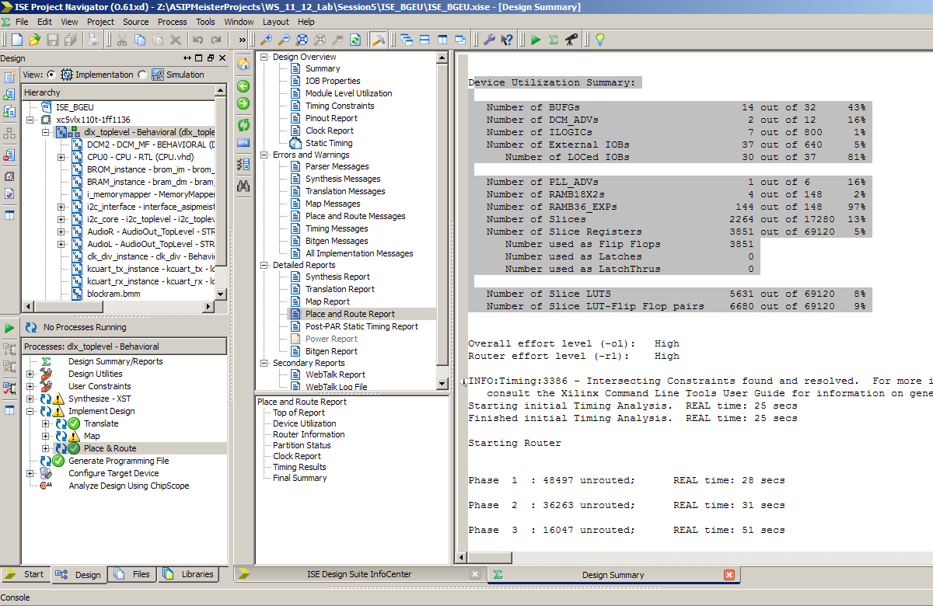

Figure ‎6‑10: Area Report

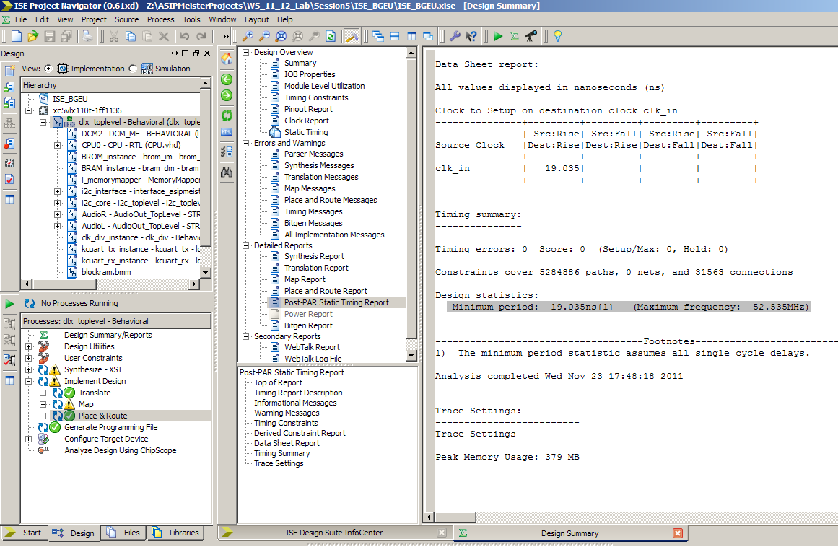

Figure ‎6‑11: Delay Report

### Getting Critical Path Report

To get the critical path, you have to analyze against the timing constraints. To do that, expand the “Place & Route” process in the sub window Process, and then expand “Generate Post-Place & Route Static Timing Report”. A double click on “Analyze Post-Place& Route Static Timing (Timing Analyzer)” will open a new window for analyzing the timing. In this window, click on “Analyze 🡪 Analyze against timing constraints” as shown in Figure 6-12.

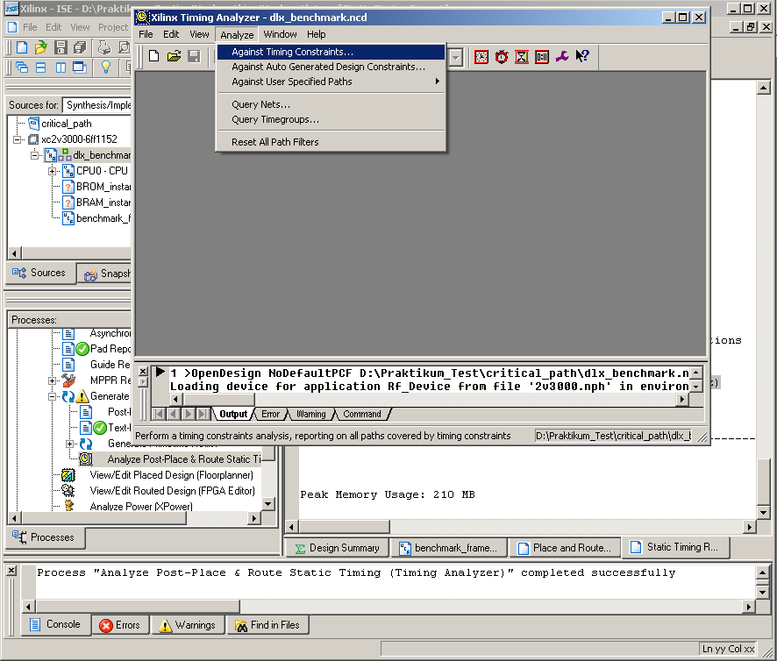

Figure ‎6‑12: Timing Analyzer Window

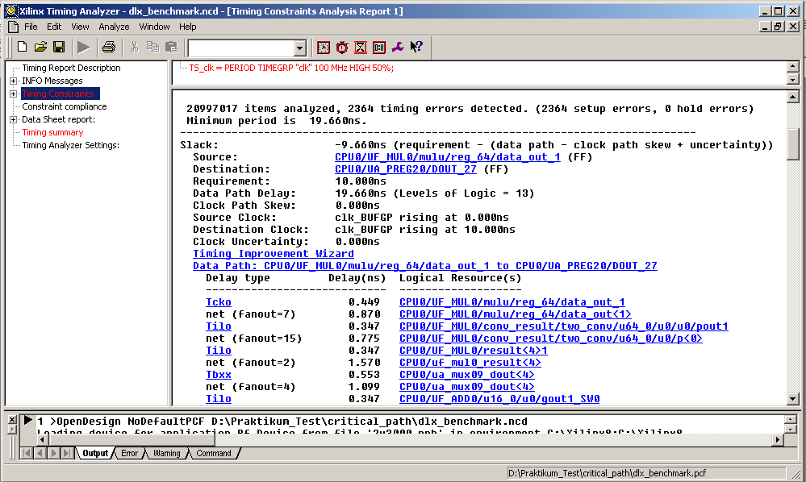

Figure ‎6‑13: Critical Path in the Xilinx Timing Analyzer

In the “Analyze against timing constraints” window, keep everything as it is and click OK. After a while, the “Timing Analyzer” window will be opened. In this window (shown in Figure 6-13), click on the “Timing constraint” and you will get the critical paths ordered from the longest to the shorter paths. For each path, you will find the total delay and the sub-delays for the signals this path consists of.

In the shown example of Figure 6-13, you can see, that the path has it’s “source” and “destination” inside the CPU0 (i.e. the instantiation of the ASIP Meister CPU, as it is named in the dlx_toplevel.vhd). When looking at the detailed signals this path consists of, you can see, that it starts in the multiplier of the CPU (MUL0, as it is named in the “Resource Declaration” in ASIP Meister), afterwards goes through a multiplexer (mux09) and then goes to the adder (ADD0, as it is named in the “Resource Declaration” in ASIP Meister).

When comparing the maximal frequency of two different CPUs you have to look at the critical paths of both CPUs to understand why maybe the one CPU is slower than the other or vice versa.

# Power Estimation

In this tutorial we will learn how to estimate the power by using ModelSim to generate the switching activity of the design, and XPower (from Xilinx) to analyze the results and generate the final power report and CosmosScope to visualize the results.

## Different Types of Power

Typically, power dissipation in a cell is subdivided into two different groups, dynamic power, and static power. **Dynamic power** is the power dissipated in a cell when the input voltage is actively transitioning. Dynamic power is further subdivided into two components switching power and internal power. **Switching power** is the power required to charge the capacitive load on the output pins of the cell. Switching power is shown in Figure 7-1, as the Isw switching current charging up the Cload capacitor. This component of power is calculated using the familiar ½ CV2 equation.

For switching power, all we need to know is Vdd and the capacitive load that is driven by the cell. Therefore, the library does not need to be characterized for this component of power dissipation.



Figure ‎7‑1: Switching Power Dissipation

**Internal power** consists of short-circuit power and power dissipated by charging the capacitive loads that are internal to the cell (not shown in the above circuit). Short-circuit power is the power that is dissipated due to the short period that paths in the cell are essentially short circuits. In the circuit shown above, Iint, that is the current path when the device is short-circuited, shows internal power. Every time the input Vin toggles, there is a short period of time where both transistors are turned on and there is a path from Vdd to ground. The longer both transistors are active, the higher the power dissipation. The circuit above is quite simple (an inverter) and there is only one path from Vdd to ground. For complex circuits, you could have dozens of potential short circuit paths. Internal power is dependent on the transition time of the input voltage Vin and the output capacitive load. These factors determine how long the short circuit is active. There is no easy formula to determine the power dissipated due to internal power, so the cell must be characterized for it.

The final component of power analysis is the **Leakage power**. In the circuit diagram in Figure 7-1, it is shown as leak current. This is the power dissipated when the circuit is in a steady state and it is due to the following factors inherent in transistors: reverse bias leakage current, sub-threshold current, or other second-order leakage power. Leakage power has become a major factor in power analysis in recent era.

At 180 nm and above, leakage power was typically less than 1% of the total power dissipation in a circuit. With 130 nm and below, the leakage power becomes a much larger factor, up to 50% of dissipated power in some cases. Leakage power should be characterized for each cell in the library.

To report the switching power, we need the switching activities of the design. The switching activity contains information about the static probability and toggle rate. The static probability can be calculated during a simulation by comparing the time a signal is at a certain logic state (state 0 or state 1) to the total time of simulation. The toggle rate is the number of transitions between logic-0 and logic-1 (or vice versa) of a design object per unit of time.

The previous power definitions can be concluded by these two equations:

Total Power = Dynamic power + Leakage power

Dynamic Power = Switching power + Internal power

## Estimating the Power Consumption

To estimate the power consumption for a specific application on a specific CPU you need to generate the switching activities, which are saved as a Value Change Dump (VCD) file. This file is generated when the project is simulated using ModelSim and the application is executed on the CPU. Then the VCD file will be used as input to the XPower tool, which finally will generate the power report. This report can be visualized using the CosmosScope visualization tool.

### Generate the VCD file using ModelSim

The VCD (Value Change Dump) file can be generated during the ModelSim simulation to capture signals switching activities as explained below:

1. Create a ModelSim project in your project’s ModelSim directory, add your CPU VHDL files from your project’s “meister/*.syn” directory, and add testbench files from the ModelSim directory, as explained in the Chapter. Remember that you should already have generated TestData.IM and TestData.DM files in your ModelSim directory using “make sim”.
2. Configure the CPU Frequency for which you want to run the power estimation. Open the ModelSim testbench (tb_browstd32.vhd), search for CLK_PERIOD, and change the value accordingly. Take care: For simulation-reasons this value corresponds to the time (in nanoseconds) of a half clock period. For example, 10 ns half period correspond to 20 ns clock period, which is 50 MHz frequency.
3. Compile the project Compile 🡪 Compile Order 🡪 Auto Generate
4. Start the simulation: VSIM > **vsim -t 1ns work.cfg**
5. Store the switching activities during the program execution in the VCD file e.g. “test.vcd” by typing: VSIM > **vcd file test.vcd**
6. Add all signals of the CPU instance: VSIM > **vcd add -r test/dut/\***
7. The entity name of the tutorial example testbench is test and the instance name of the device under test is dut. Using the -r switch with ModelSim “vcd add” command will result in a large but significantly more accurate VCD file. VCD files can grow quite large for larger designs or even for smaller designs if the simulation time is long.
8. Run the simulation: VSIM > **run -all**
9. The switching activities will be saved in “test.vcd” file.

### Generating the Power Report Using xPower

The second step is to create an ISE project that you want to analyze for power consumption. Create a new project and add only the CPU files from the ASIP Meister “meister/xxx.syn” directory to it. In the “Processes”-tree of your top-level design and under “Implement Design/Place & Route”, click on “Analyze Power Distribution (xPower Analyzer)”. This will open the xPower window. Now, click on “File>open Design”, in the “Design” file, you have to add your .ncd file e.g. toplevel.ncd” and in “Simulation Activity” file, you have to add the .vcd file that you generated in the previous step. Finally, in the “Physical Constraint” file, you can add the .pcf file for you project e.g. “toplevel.pcf” as shown in Figure 7-2. As soon as you click OK, the XPower tool will analyze the files and gives you a summary about the power consumption in your design (like the Leakage power and the total power). On the right side, you find “By Clock Domain”. Here you see the frequency in (MHz). The clock frequency should be the same frequency that you used in testbench during VCD file generated as shown in Figure 7-3.

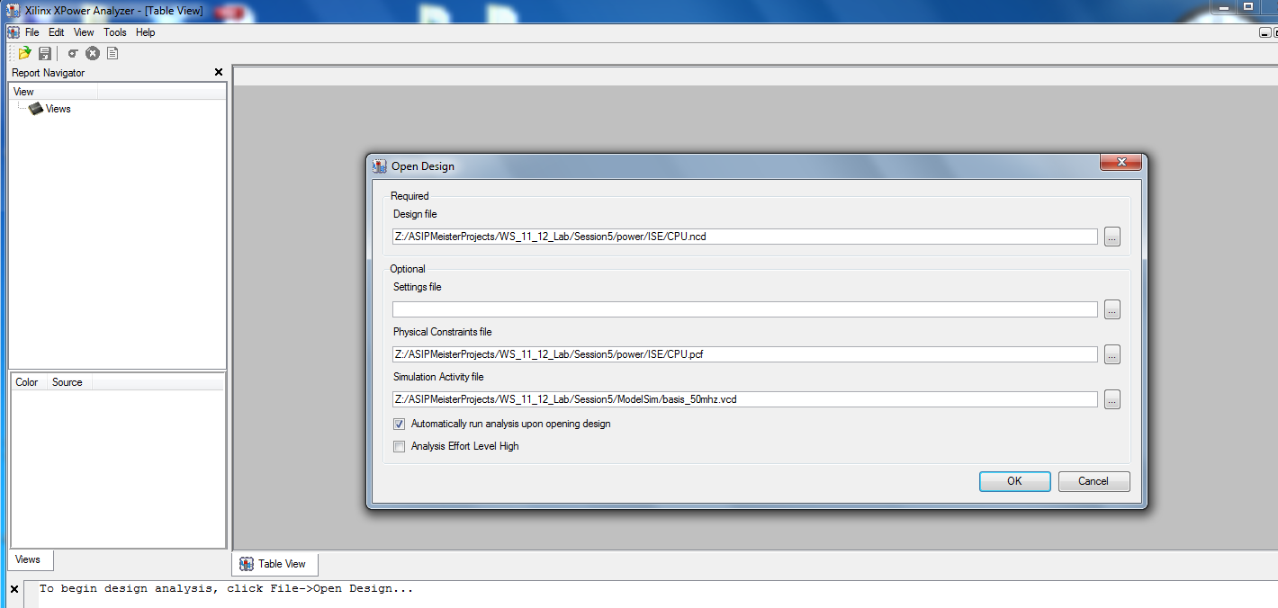

Figure ‎7‑2: Preparing xPower Tool

***Important Note:***

It is worthy to know that the total power number that you get from xPower is the Dynamic power plus the Leakage power. When you read the leakage power consumption, you will see that is much higher than the dynamic power. This is because the leakage power is total leakage power consumed in the whole FPGA chip even if your design is small and it occupies a very small part of the chip. Since Vitrex5 does not have a power gating, the leakage power is always consumed and high.

For that, when you take the power number for your design, you have to consider only the dynamic power in order to make your results comparable and see clearly how much you have to pay for your custom instructions in terms of power.

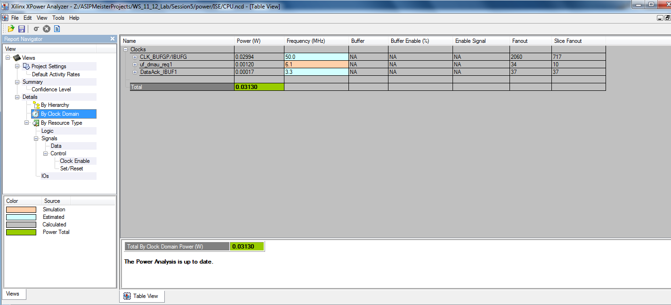

Figure ‎7‑3: Checking the CPU Frequency

To compare the power consumption between two processors, the average value will not give correct information because every processor can execute the same application with different execution time, as shown in Figure 7-3. In this case, we need to consider the energy. The energy is defined as the power consumed during whole execution time, and given as:

🡺 E = P * T



Figure ‎7‑4: Power Dissipation as Average Value



Figure ‎7‑5: Energy Comparison between two Processors

# Extended GCC Compiler

The Extended GCC compiler development system is a compiler generator that automatically creates an executable compiler out of an architecture description. In our case, ASIP Meister automatically creates this architecture description itself and an afterwards running program provided by the developers of ASIP Meister. In this chapter, some basics about the buildup of retargetable compilers, creation and usage of a GCC compiler for our specific ASIP Meister CPU’s are explained.

## Basics about Retargetable Compilers

Figure ‎8‑1: A Typical Buildup for a Retargetable Compiler



A typical retargetable compiler is separated into **three** phases, as shown in Figure ‎8‑1. The first stage is architecture independent, but source language dependent. This phase reads the source code, inspects it for syntactic and semantic correctness, and transforms it into the second phase, the intermediate representation (IR). This IR is as well source language independent as architecture independent and it is used to perform the optimizations. This implies, that the optimizations can be easily reused, if the source language or the architecture changes. The third phase is source language independent, but highly architecture dependent. This backend first transforms the IR into a low-level form. That means, that high-level structures, like polymorphic procedure calls are replaced by jump tables or that complex data structures are disassembled into elementary memory accesses. Afterwards the final assembly code has to be created. This part is separated into **three** steps. In the first step, code has to be selected out of the lowered IR. This code selection is not unique, as there are always different possibilities to represent some statements in assembly language. This code selection works with virtual registers, which are replaced by real registers in the second step. This register allocation might lead to additional stack accesses for swapping values out, if no free real register can be found to hold the value of a virtual register. In the third step, the code is scheduled, to minimize penalties for data dependencies. Every step from this code selection has a great influence on the outcome of the other steps. The sequence of these steps is not determined and different compilers work with different sequences. The above given order is just exemplary.

## Creating the Extended GCC Compiler in ASIPmeister

The ASIP Meister complier generation supports the base processor Brownie. In order for the compiler to generate instructions that are extended from the Brownie processor, some definitions are necessary. Using [C Definitions], you can define the C description specifications that are supported by the ASIP Meister compiler and the C description variables that support the instructions extended from the Brownie processor. The “Compiler Generation” is possible only for the processor extending a base processor Brownie. One can define how to represent the extension instruction added to the base processor Brownie in C code during the “C Definition” stage. Extension instruction definition enables a complier to output assembly code complying with the extension instruction.

### C Definition

On the “Ckf Prototype” tab of “C Definition” sub-window in ASIPmeister, you can define all the newly defined instructions as described in the Page-65 of [TUT] and on the Page-57 of [UM]

### Compiler Generation

At “Compiler Generation” stage in ASIPmeister, the processor compiler and the Binutils can be generated. The processes involved in the “Compiler Generation” phase are as follows.

1. Input Description Generation: select and run.

2. GNU Tools Generation: select and run.

If you select “Input Description Generation” from the drop down list, the compiler extended description will be generated. After the generation terminates successfully, if the design data file was called” browstd32.pdb”, a new directory called” browstd32.swgen” will be generated inside ”meister” directory, and inside this directory the compiler extended description is generated in a file named ” browstd32.xml”. The generated compiler and Binutils supports the Ckf defined at “C Definition”. After you select “GNU Tools Generation” and the generation terminates successfully, the compiler and the Binutils will be generated in default directory called ”browstd32.swgen” in the “meister” directory.

### Using custom instruction in the C Program

Once the custom instruction is defined in the “C Definition”, they can be used in the C program as described on the Page-63 in [UM] and on Page-68 in [TUT]. There are two methods to use the custom instruction here:

1. When you want to write the extended instruction description in C code, you have to add “__builtin_brownie32_” directive to the “ckf definition”. An example is demonstrated in the following for a custom instruction AVG with three parameters (AGV rd, rs1, rs2).

int a=12,b=23,c;

c = __builtin_brownie32_AVG(a, b);

1. In some cases, above method does not work, e.g., when an instruction returns a “void”. Standard inline assembly directives can be used to write the extended custom instruction, as follows:

__asm__ volatile (

"avg %[my_out], %[my_op1], %[my_op2]\n"

: [my_out] "=&r" (c)

: [my_op1] "r" (a),[my_op2] "r" (b)

);

### Using the Extended GCC Compiler

In the lab, the Makefile is automatically doing all the steps. However, you can also use the generated compiler separately; the following demonstrates a method for cross compiling a C program file called “bubble.c”.

1. First, you have to add the path “browstd32.swgen/bin” to the $PATH environment variable.

export COMPILER_DIR=/brownie/meister/browstd32.swgen/bin

or

export PATH=/brownie/meister/browstd32.swgen/bin:$PATH

1. Compile the C program into .s assembly file

${COMPILER_DIR}/brownie32-elf-gcc -S -combine -O3 bubble.c -o bubble.s

1. Assemble bubble.s file into .o object file. Also, assemble startup.s (startup code) and handler.s (interrupt handler) file to object files.

${COMPILER_DIR}/brownie32-elf-as -o startup.o startup.s;

${COMPILER_DIR}/brownie32-elf-as -o handler.o handler.s;

${COMPILER_DIR}/brownie32-elf-as -o bubble.o bubble.s;

1. Link the object files using the linker script “browtb.x”. This script declares some important information about the stack pointer, text and data sections, program counter address after the resetting the CPU.

${COMPILER_DIR}/brownie32-elf-ld -o bubble -T browtb.x bubble_uart.o startup.o handler.o

1. Converting compiled object file to memory image of the C program. Use “gccout2img” for a file in elf format obtained through normal compilation. The script “gccout2img” outputs *TestData.IM* and *TestData.DM*, with which the user can perform simplified test simulations.

gccout2img bubble

## Library with Standard Functions for ASIP Meister / GCC / Hardware Prototype

Many applications use some standard library calls like *printf*, *malloc* or *atoi* that are not declared in the standard of the C programming language, but which are nevertheless declared in the C standard library. Now, GCC is a compiler for the C language and does not provide an implementation for the standard library (in fact there are some huge fragments that would have to be adapted to our specific environment, what has not been done due to the complexity of a full run-time implementation).

To close the gap between a plain C compiler and the wish of letting complex algorithms run in hardware and produce understandable output we are providing some basic *stdlib* functionality, which is dedicated to the environment of ASIP Meister, the GCC compiler and our hardware prototype. This basic *stdlib* functionality is extended on demand to reflect the latest changes of our environment. Thus, it is not explained exhaustively or in high detail. Instead, the underlying concepts and the needed steps for using the basic *stdlib* library is explained here, plus some of the main functions for using our touch screen LCD with some examples.

All typical functionalities of our *stdlib* implementation are available in the directory */home/asip00/epp/StdLib/.* The functionality is encapsulated into a header file that is providing the interface and a documentation of the functionality and a C file for implementing the header. You can use these files by linking/copying them into your application project subdirectory and using “*make sim*” to compile your application and the *stdlib* files into one binary and simulation file, as it will be shown in the example below. Linking to the files instead of copying them has the advantage, that you always have the latest version of these files in your project. Some of the files in the *stdlib* directory have dependencies to other files of this directory. Thus, you can get a compiler error, that a specific header file was not found when you try to compile your project. You then have to manually link to the dependent files as well. Just linking to all available files is generally not a good idea, as this makes the compilation process take longer and it increases the needed memory size of your application.

Now we will demonstrate how you can create a small application that is using the LCD of the hardware prototype:

* Create a new subdirectory inside the application directory of your ASIP Meister project and change into this new directory
* Copy or Link to *lib_lcd*, *loadStorByte* and *string*, by executing:

ln –s /home/asip00/epp/StdLib/lib_lcd_320.* .

ln –s /home/asip00/epp/StdLib/loadStoreByte.* .

ln –s /home/asip00/epp/StdLib/string.* .

*lib_lcd* has a dependency to *loadStoreByte* and *string*, that is why you need both.

The *lib_lcd_320* exists in different C implementations, depending on your target LCD. One C file is for the LCD with a 240x128 resolution, the other one is for the 320x240 resolution, and the last one is for the dlxsim simulation. Make sure that at most, one of these C files is available in your application subdirectory; otherwise, the linker will complain about multiple implementations (one per C file) of the LCD functionality.

* Prepare an “*env_settings*” file, as shown in Chapter ‎6.4.
* Add a new C file that contains your main method. This main method will contain the following code as example:

t_print(“Hello World\r\n”);

t_printInt(42);

The LCD needs the “*\r\n*” in the string, as it is handling carriage return (\r) and line feed (\n) independently.

* Compile your project by executing “*make sim*”.

The resulting program can be simulated with dlxsim or ModelSim or it can be uploaded to the hardware prototype (explained in Chapter ‎6.4) depending on the selected LCD library.

After you have once compiled a C-Code that rarely changes (e.g. the libraries), you can reuse the created assembly code for future compilations. That will enormously speed up the whole compilation process. This is especially good for all applications in the *StdLib* directory. Just compile them one time with “*make sim*” and then copy the created .*asm* file from the “*BUILD_SIM*” directory to the directory of your other application files, but name it .s instead of .asm. Then remove the C code (but not the header) to make sure the code does not exist twice (in the C code and in the Assembly file). For instance:

cp BUILD_SIM/loadStoreByte.asm loadStoreByte.s

rm loadStoreByte.c

However, when moving from dlxsim to FPGA implementation then you have to delete these assembly files, link to the C files, and recompile them. If you are often switching between dlxsim and FPGA, then it may be beneficial to create two application directories with the different libraries and “*env_settings*” specified for dlxsim and FPGA respectively and using the same application-specific source code in both directories (e.g. with a link).

As mentioned above, the “*lib_lcd*” exists in different variants. The files “*lib_lcd_240.c*” and “*lib_lcd_320.c*” are for the FPGA prototype. They implement the real protocol for communicating with the I2C bus and thus with the LCD. For a simulation, we cannot use this implementation, as it is waiting for certain responses from I2C/LCD, but in dlxsim/ModelSim simulation, these answers will never appear. We have therefore implemented “*lib_lcd_­dlxsim.c*” which simply writes every single character that is send to the LCD to an output file (a virtual LCD). This is a very good debugging possibility for printing text, although it is not helpful for any graphic output to the LCD (e.g. lines, bars …), as these control words are hard to understand manually. For dlxsim, the characters are either printed to the console whenever they appear or they are collected and printed to a file (parameter “-lf” in Chapter ‎3.2.1). For ModelSim, the characters are printed to a file “*lcd.out*” in the ModelSim directory. The header file “*lib_lcd.h*” is valid for all C files, but you have to make sure, that at most one of the both C files is available in the directory when compiling with “*make sim*”. Otherwise, you will get two implementations of the LCD functions and the assembler will complain, that he cannot decide which one to choose.

### Functions of the LCD Library

This chapter summarizes some of the available functions to access the features of the LCD of our hardware prototyping board. The library also contains some high-level functionality that is useful, but introduces a dependency to “*string.c*”. Therefore, this library has to be provided as well when using “*lib_lcd*”.

The most important basic I/O instructions are: “*t_print(char*)”*, “*t_printInt(int)”*, and “*t_printHex(int value, int digits)”*. You can use them to print strings and numbers, for instance:

char tempString[] = “\r\n\t\t”;

t_print(“Hello World!”);

t_print(tempString);

t_printInt(23);

t_print(“ = “);

t_printHex(23, 0);

t_print(tempString)

t_printInt(42);

t_print(“ = “);

t_printHex(42, 4);

The “*printHex()”* function can trim the output to a given number of digits (4 in this case). To not trim the number of digits you have to give ‘0’ as parameter. The output of the above example looks like:

Hello World!

23 = 0x17

42 = 0x002A

In the following, we describe further functions of the LCD. Some of them are generally sending a command to the LCD (you have to use the LCD manual [eDIP] to find the available commands) and some of them are offering typical commands (e.g. drawline) as convenience functions.

int checkbuffer()

This function returns the number of available bytes in the send buffer of the LCD. It can be used to wait for a return value of the LCD. For example when pressing a button on the touch panel, a value of this button is written to the LCD send buffer.

int getbytes (char* dest, int bytes_to_read)

This reads a specific number of bytes from the send buffer. With the “*checkbuffer”* function, you can test how many bytes are available in the buffer.

int sendcommand ( const char cmd0, const char cmd1, const int options[], const char text[],  
int intcount, int charcount, int address)

This is a general function for sending commands to the LCD. The following commands internally use “*sendcommand”* to realize their functionality. The parameters of “*sendcommand”* are:

* Two chars, specifying the command
* Depending on the type of the command, some options
* Depending on the type of the command a string with a predefined size
* The address of the LCD (defined in lib_lcd.c)

int t_print (const char* str)

This function writes a string to the LCD terminal. The “t_” indicates a command for the console mode of the LCD, compared to the graphic mode (g_) of the LCD, which is explained later.

int t_cursor (int onoff)

Turns on (1) or off (0) the blinking cursor of the terminal.

int t_enable (int onoff)

Turns the display on (1) or off (0). When the display is turned off, all submitted data is ignored. Previously sent data (when the display was on) is buffered and will become visible again, after the display will become turned on again.

int g_print (const char* str, int x, int y)

Writes a string to the coordinates (x, y). You must not send control signals like \n in this function. They are only available for the t_print function.

int g_drawrect (int x1, int y1, int x2, int y2)

int g_drawline (int x1, int y1, int x2, int y2)

Draws a rectangle/line.

int g_makebar ( int x1, int y1, int x2, int y2, int low_val, int high_val, int init_val, int type, int fill_type, int touch)

Creates a bar graph at the defined coordinates. “low_val” and “high_val” describe the minimal and maximal (at most 254) value of the bar graph. “init_val” defines the initial value and “type” and “fill_type” adjust the appearance of the graph. Type=1 will draw a bar in a box and the “*fill_type*” (in the range of 1 to 15) then defines the fill pattern. Type=3 will draw a line in a box and the “*fill_type*” will then define the thickness of the line. For more details refer too [LCD].

With “touch” you can define, whether the bar graph will be user changeable by the touch screen. Every bar graph gets a unique number, which is returned by the function. At most 32 bar graphs are supported by the display. When the touch screen functionality is activated and the user changes the value of the bar graph, the LCD automatically writes the number of the changed bar graph and its modified value to the buffer, from where it can be received with the checkbuffer and getbytes function.

int g_setbar (int barnum, int value)

Sets an existing bar graph to a specific value.

int g_makeswitch ( const char* str, int x1, int y1, int x2, int y2, int down, int up)

Creates a switch (button) with a label. The parameter “str” contains this label, preceded by a control char which defines the alignment of the label. “C” means centered, “L” means left- and “R” means right-aligned. down and up define the code, which the LCD will write into the send buffer, when the button is pressed or released. When 0 is provided as parameter for up or down, then nothing will be written to the buffer for the specific activity.

int g_makeradiogroup (int group_number)

A new defined switch can be assigned to a specific radio group. A radio group automatically makes sure, that at most one switch of the group is pressed.

int g_makemenubutton ( const char* str, int x1, int y1, int x2, int y2, int down, int up, int select, int space)

A menu item is created. With “str” you can define the appearance and the menu entries. The first character defines the direction in which the menu will open (“L”: left, “R”: right, “O” up, “u”: down). The second char defines the alignment of label on the menu item (“C”: centered, “L”: left aligned, “R”: right aligned). The labels of the menu entries follow afterwards and are separated by a “|” sign. “down” defines the value that will be written to the buffer, when the menu item is pressed and up defines the value that will be written to the buffer, when the menu is closed, without choosing a specific entry (aborted). “select” defines the base value that is used to compute the value that will be written to the LCD buffer, when a menu entry is chosen. This value is computed as: base value + entry number – 1. “space” defines the gap in pixels between the menu entries. This is a global value, thus it will also change the appearance of already existing menus.

### Functions of Further Libraries

Besides the LCD, further functionality and helping functions are available. They will be summarizes in this section to give an overview of the available features. You should look into the libraries to find out more.

**lib_uart:** besides printing to LCD, you may also print to the UART port using the “*u_print”*, “*u_printInt”*, and “*u_printHex”* functions (similar to “*t_print”* etc.). You can read from the UART port with “*u_getbytes”*. However, you need a HyperTerminal running at the pc to which the UART is connected (see Chapter ‎6.4.2 for details about the HyperTerminal). In Modelsim, uart.out is automatically created while for dlxsim you can pass the parameter “-uf” to print text in a file instead of appearing on the console.

**lib_audio:** you can write uncompressed PCM audio data to an audio port using the “audioAddressR{L|R}” pointers. The corresponding sample width of the corresponding IP core in the VHDL-framework (default 16 Bit) can be configured in “*AudioOut_Types.vhd”* and the sampling rate (default 40 KHz) can be configured in “*dlx_Toplevel.vhd”* (search for ‘i_audio_out’).

**lib_clock:** you can use the pointer “*clockAddress*” to read and write to access a special register that automatically increments by one in each cycle. You can use this to benchmark the performance of a certain C-Code by e.g. writing a ‘0’ to it to start the benchmark and to read it again at the end of the benchmark. Make sure that the code that will be benchmarked does not contain any unnecessary I/O instructions (e.g. “*t_print”*) as they are extremely slow.

**String:** contains some typical string manipulation functions, e.g. “*strlen”*, “*strcat”*, “*strcpy”* … It additionally contains two functions to convert an integer number to a string representation, as it is used in the I/O libraries, e.g. “*t_printInt”* or “*u_printHex”*.

### Changing the Frequency

In order to change the frequency of your design and see if it still works or not (required for the last Session), the Framework contains a DCM (Digital Clock Manager) that generates five different clocks. By changing the knob on the external PCB, a multiplexer (in the “dlx_toplevel.vdh” file) selects the corresponding frequency that you want to apply on your design.

|  |  |
| --- | --- |
| Knop value | Frequency (MHz) |
| 0 | 100 |
| 1 | 80 |
| 2 | 66 |
| 3 | 50 |
| 4 | 40 |
| 5 | 25 |
| Else | 100 |

Figure ‎8‑1: Knob Position & Corresponding Frequencies

Table of Figures

Figure ‎1‑1 GPPs, ASIPs and ASICs [Henkel06] 5

Figure ‎1‑2: Typical ASIP Design Flow [Henkel03] 6

Figure ‎1‑3: Constraints for *valid* Custom Instructions 8

Figure ‎2‑1: The Directory Structure for all ASIP Meister Projects 15

Figure ‎2‑2: Makefile Options and Parameters 17

Figure ‎2‑3: The Directory Structure for a Specific ASIP Meister Project 18

Figure ‎2‑4: The Files in a Project Directory 20

Figure ‎2‑5: The Configurable Settings for an ASIP Meister Project 21

Figure ‎3‑1: Brownie STD 32 Architecture Parameters 23

Figure ‎3‑2: BROWSTD32 Pipeline Example with a Data Dependency 24

Figure ‎3‑3: Instruction Formats and Classes of the BROWSTD32 Architecture 25

Figure ‎3‑4: Summary of All Assembly Instructions in the *browstd32* Processor 26

Figure ‎3‑5: Summary of Helpful dlxsim Starting Parameters 28

Figure ‎3‑6: Summary of Available dlxsim Instruction Formats 30

Figure ‎3‑7: Summary of Typical dlxsim Commands 31

Figure ‎3‑8: Summary of Available dlxsim Statistics 32

Figure ‎4‑1: ASIP Meister Input and Output 34

Figure ‎4‑2: ASIPmeister main window 35

Figure ‎5‑1: Creating a ModelSim Project 48

Figure ‎5‑2: Adding Files to a ModelSim Project 48

Figure ‎5‑3: Compiling the Project 50

Figure ‎5‑4: Starting the ModelSim Simulation 50

Figure ‎5‑5: Running the ModelSim Simulation 51

Figure ‎5‑6: ModelSim Waveforms 52

Figure ‎5‑7: Explanation of the Signals in the ModelSim Waveform 53

Figure ‎6‑1: XUPV5-LX110T Prototyping Board from Xilinx [HWAFX] 55

Figure ‎6‑2: ISE Device Properties 56

Figure ‎6‑3: Add Sources 57

Figure ‎6‑4: ISE Project Overview 57

Figure ‎6‑5: Uploading the Bitstream with iMPACT 59

Figure ‎6‑6: HyperTerminal settings 61

Figure ‎6‑7: 4-Input 1-Output Look-Up Table (4-LUT) [Kalenteridis04] 63

Figure ‎6‑8: CLBs, Slices, and LUTs in a Virtex II FPGA [XUG002] 63

Figure ‎6‑9: Array of CLBs and PSMs [XDS060] 64

Figure ‎6‑10: Area Report 65

Figure ‎6‑11: Delay Report 65

Figure ‎6‑12: Timing Analyzer Window 66

Figure ‎6‑13: Critical Path in the Xilinx Timing Analyzer 66

Figure ‎7‑1: Switching Power Dissipation 68

Figure ‎7‑2: Preparing xPower Tool 70

Figure ‎7‑3: Checking the CPU Frequency 71

Figure ‎7‑4: Power Dissipation as Average Value 72

Figure ‎7‑5: Energy Comparison between two Processors 72

Figure ‎8‑1: Knop Position & Corresponding Frequencies 81

References

[CES] Homepage of the Chair for Embedded Systems at the University of Karlsruhe: <http://ces.univ-karlsruhe.de/>

[Henkel03] Joerg Henkel “Closing the SoC Design Gap”; IEEE Computer Volume 36, Issue 9, September 2003, Pages: 119-121.

[Henkel06] Joerg Henkel “Design and Architectures for Embedded Systems (ESII)”, University of Karlsruhe, WS06/07

[ASIPMeister] ASIP Meister Homepage (note: this is the new homepage from the founded company; the old academic homepage no longer exists): <http://www.asip-solutions.com/>

[HWAFX] Virtex-II FF1152 Prototype Board: <http://www.xilinx.com/univ/xupv5-lx110t.htm>

[Hennessy96] John L. Hennessy, David A Patterson “Computer Architecture – A Quantitative Approach” 2nd edition 1996; Morgan Kaufmann Publishers, Inc.

[Shaaban01] Muhammad Shaaban “The DLX Architecture”, lecture on ‘Computer Architecture’ <http://meseec.ce.rit.edu/eecc551-winter2001/551-12-5-2001.pdf>

[Sailer96] Philip M. Sailer, David R. Kaeli “The DLX Instruction Set Architecture Handbook”, 1996 Morgan Kaufmann Publishers, Inc.

[DLXsim] Handbook for DLXsim: <http://heather.cs.ucdavis.edu/~matloff/dlx.html>

[DLX-Package] A composition of the used programs DLXsim, DLXview, DLXgui and DLXcc:  
<http://www.ra.informatik.uni-stuttgart.de/~rainer/Lehre/ROTI01/DLX/>

[Kalenteridis04] Kalenteridis et al. “A complete platform and toolset for system implementation on fine-grained reconfigurable hardware“, Microprocessors and Microsystems 2004

[XUG002] Xilinx Corp. “UG002: Virtex-II Platform FPGA User Guide” <http://www.xilinx.com/support/documentation/user_guides/ug002.pdf>

[XDS060] Xilinx Corp. “DS060: Spartan and Spartan-XL Families Field Programmable Gate Arrays“ <http://www.xilinx.com/support/documentation/data_sheets/ds060.pdf>

[FSM] Tutorial for VHDL Final State Machines with synchronous and asynchronous process: [www.gaisler.com/doc/vhdl2proc.pdf](http://www.gaisler.com/doc/vhdl2proc.pdf)

[CoSy] Homepage from ACE, the developers of the CoSy compiler: [www.ace.nl](http://www.ace.nl)

[eDIP] Data Sheets for the eDIP LCDs <http://www.lcd-module.de/deu/dip/edip.htm>

[RM] Documents /BrownieSTD32_Spec_en.pdf

[TUT] Documents /AM_tutorial_en.pdf

[UM] Documents/AM_usersmanual_en.pdf

[eDIP] Data Sheets for the eDIP LCDs <http://www.lcd-module.de/deu/dip/edip.htm>

1. There is another type: ctrl which is used for multi cycle instructions